Press Release
2022-130

Schmitz Cargobull AG
Hattrick! Schmitz Cargobull wins "Best Brand 2022
Once again, the readers of the ETM publishing house vote Europe's leading trailer manufacturer into first place, and this time in no less than three categories

June 2022 - For the first time, Schmitz Cargobull has won the "Best Brand Awards" in the readers' poll of the German ETM publishing house in three categories and is thus the front-runner for semi-trailer Box Body/Reefer, semi-trailer Curtainsider and, for the first time, also the winner in the category semi-trailer tipper.
Almost 6,000 readers of the trade magazines "Fernfahrer", "lastauto omnibus" and "trans aktuell" participated in the voting.

"The fact that we have received the awards in all three semi-trailer categories this year is something special and fills us with pride and joy", said Andreas Schmitz, CEO of Schmitz Cargobull AG at the award ceremony on Wednesday, 1 June 2022 in Berlin. "These awards are not only a confirmation of our customer-oriented products and services, but also of the reliability and innovative strength of our employees, who are always working on solutions for the lowest TCO (Total Cost of Ownership) and thus for the profitability of our customers. Our thanks go to the customers and readers who have remained loyal to the Schmitz Cargobull brand, especially under these difficult circumstances."

Schmitz Cargobull remains in second place for refrigeration units, repeating its success from previous years. "We were able to further reduce the gap to the first-place finisher this year and have further extended that to the third-place finisher," says Schmitz. "With our S.CU cooling unit, we are continuing to work towards

2022-130
achieving a top position here as well. Our high-performance cooling unit, the FERROPLAST box body in combination with the web-based monitoring system and the unique proactive service management are a guarantee of success for temperature-controlled transport".

For the 26th time, the readers of the German trade magazines “lastauto omnibus”, “trans aktuell” and “Fernfahrer” have chosen the best commercial vehicles.
The winning brands in a total of 29 categories were determined, together with DEKRA, under notarial supervision. Readers evaluate brand image and product quality. The results of the survey provide evidence of customer preferences and are therefore considered an important indicator for the industry.

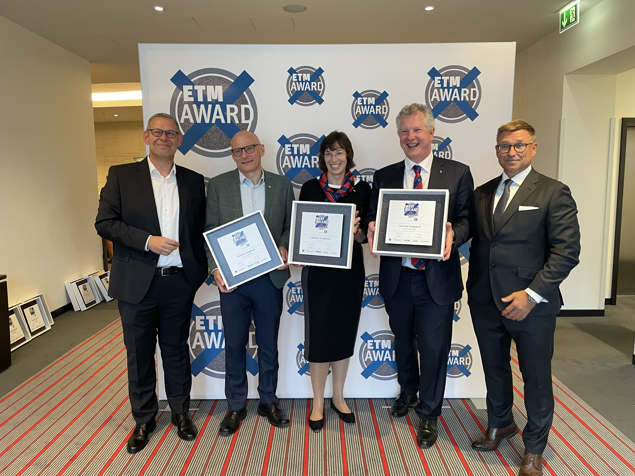

From left: Oliver Trost, Managing Director ETM Verlag, Søren Danielsen, Manager Digital Services Schmitz Cargobull,
Anna Stuhlmeier, Head of Marketing Communications, Press & PR Schmitz Cargobull, Andreas Schmitz, CEO Schmitz Cargobull, Bert Brandenburg, Managing Director ETM Verlag

About Schmitz Cargobull
With an annual production of around 42,500 trailers and with around 5,700 employees, Schmitz Cargobull AG is Europe’s leading manufacturer of semi-trailers, trailers and truck bodies for temperature-controlled freight, general cargo and bulk goods. The company achieved sales of approximately €1.74 billion in the 2020/21 financial year. As a pioneer in the industry, the North German company developed a comprehensive brand strategy early on and consistently established quality standards spanning every level: from research and development, through production and service contracts, to trailer telematics, financing, spare parts, and used vehicles.

The Schmitz Cargobull press team:
Anna Stuhlmeier +49 2558 81-1340 I anna.stuhlmeier@cargobull.com
Andrea Beckonert +49 2558 81-1321 I andrea.beckonert@cargobull.com
Silke Hesener: +49 2558 81-1501 I silke.hesener@cargobull.com

