Press Release
2019-107

Image Award 2019: Schmitz Cargobull AG at the top again
Image Award 2019 - The award goes to
Schmitz Cargobull
First place in the category “Commercial vehicle bodies” for the brand with the blue elephant

February 2019 – With its award in the category “Commercial vehicle bodies”, Schmitz Cargobull once again demonstrates its leading position in the segment. The market leader has won the coveted Image Award presented by the German trade magazine VerkehrsRundschau for the eighth time and for the first time in the category “Commercial vehicle bodies”.
Boris Billich, Chief Sales Officer at Schmitz Cargobull AG, accepted the award for the first place at the ceremony in Munich. “There is a reason why we receive such excellent ratings in this category”, says Boris Billich with certainty, “Customers are impressed with our innovative products and reliable services. Schmitz Cargobull’s experts develop professional and customer-oriented practical solutions for urban transport. Over the years, we have consistently expanded our production network for the M.KO truck bodies. We have also made massive investments at our plants in Panevėžys/Lithuania and Toddin/Germany in recent years. This includes the new foaming line for FERROPLAST® panels.”

In October 2018, two additional production lines were commissioned at Panevėžys for M.KO truck bodies and M.KO box kits. This triples the plant’s technical capacity from around 10 units in 2017 to 30 units per day as of April 2019. “The Lithuanian plant has developed very successfully as a supplier for the European market and in production of box kits and special solutions for our customers”, says Boris Billich. This is reflected by successful supply concepts for M.KO box kits agreed with diverse OEMs. Standardised services such as warranty and customer service processing throughout the entire Schmitz Cargobull Group round out the total package for the customers.

2019-107
“We are not only successful on the European market but also throughout the world and work with renowned and leading vehicle manufacturing partners in New Zealand, Australia, South Africa and Canada”, continues Boris Billich.
Schmitz Cargobull also proudly took second place in the “Telematics OEM” category with its TrailerConnect® telematics solution. Boris Billich: “This success demonstrates that telematics systems have now become an essential factor when purchasing a vehicle and that our trailer telematics convince customers as they provide true added value.”
The coveted Image Award is presented annually by the renowned German trade magazine VerkehrsRundschau. In a representative survey, the market research institute Kleffmann interviewed more than 663 fleet managers about the image of the most important providers of commercial vehicles, products and services. This year’s image awards included 110 brands in 12 categories: vans, light and heavy trucks, trailers/semi-trailers, truck bodies, tyres, fuel cards, truck and trailer rental, telematics OEM’s and third parties along with forklifts/loading/storage equipment as well as truck loading cranes.

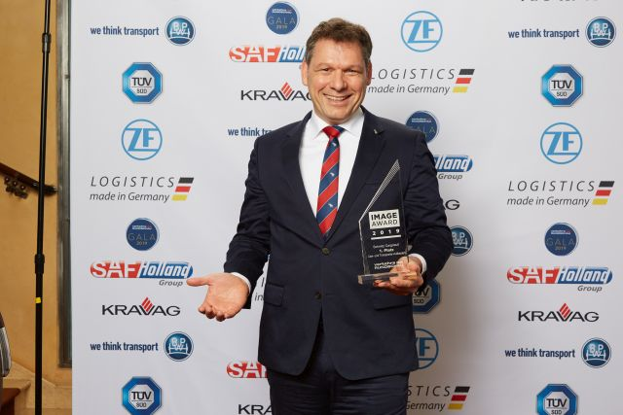
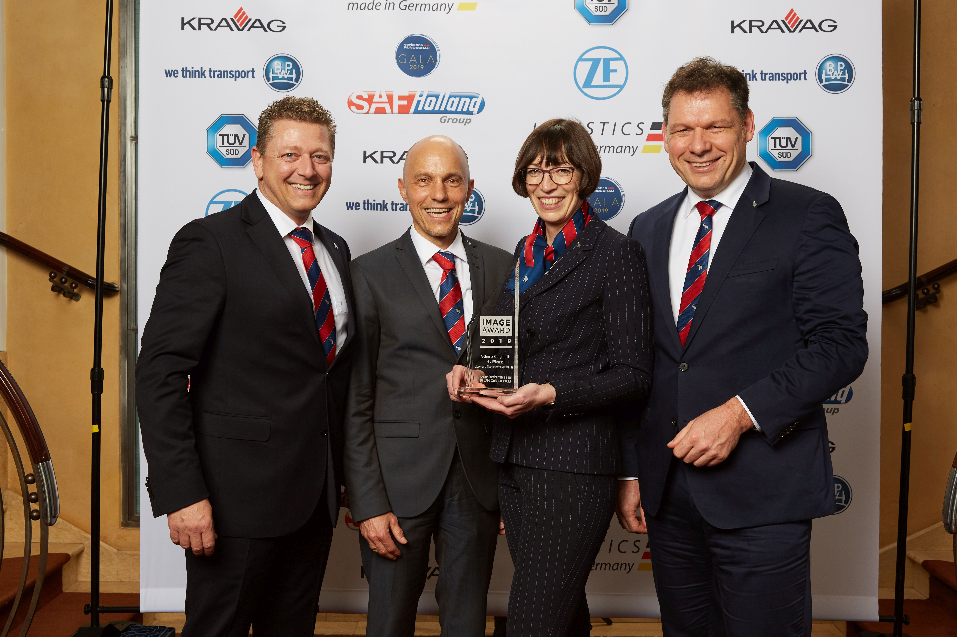
Gala2019JS-SCB_BorisBillich Gala2019JS-SCB_group

Caption Gala2019JS-SCB_BorisBillich: Boris Billich, Chief Sales Officer Schmitz Cargobull AG, is delighted to be awarded first place in the Truck Bodies category

Caption Happy about the first place in the category Truck Bodies: (from right to left) Boris Billich, Chief Sales Officer; Anna Stuhlmeier, Head of Marketing Communications & Press, PR; Jörg Irsfeld, Head of International Key Account Management - all Schmitz Cargobull AG - Marco Reichwein, CEO Cargobull Telematics
photos: © VerkehrsRundschau/Jan Scheutzow

About Schmitz Cargobull
With an annual production of some 61,000 trailers and around 6,400 employees, Schmitz Cargobull AG is Europe's leading manufacturer of semi-trailers, trailers and truck bodies for temperature-controlled freight, general cargo and bulk goods. The company achieved sales of approx. € 2.2 billion in the 2017/2018 financial year. As a pioneer in the industry, the North German company developed a comprehensive brand strategy early on and consistently established quality standards spanning every level: from research and development, to production and service contracts, trailer telematics, financing, spare parts and used vehicles.

The Schmitz Cargobull press team:
Anna Stuhlmeier: +49 2558 81-1340 I anna.stuhlmeier@cargobull.com
Andrea Beckonert: +49 2558 81-1321 I andrea.beckonert@cargobull.com
Silke Hesener: +49 2558 81-1501 I silke.hesener@cargobull.com

