Press Release
2025-101

Schmitz Cargobull AG
Schmitz Cargobull to expand its Vreden delivery centre for refrigerated and box body semi-trailers
Approved building project expected to speed up vehicle delivery and reduce impact on the environment
January 2025 – Schmitz Cargobull, Europe’s leading manufacturer of semi-trailers, and the Mayor of Vreden, Dr Tom Tenostendarp, are delighted that planning permission has been granted for an extension to Schmitz Cargobull’s delivery area for refrigerated and box body semi-trailers at the company’s site in Vreden (Germany).

Construction is due to begin in the first half of 2025 and will take around one year. With this significant investment, an additional area of around 11 hectares with 750 new vehicle parking spaces will be created. As a result, the vehicle delivery process will be sped up, which will also protect the environment by reducing the amount of transportation needed.

The expansion will reduce the number of external parking areas rented in the vicinity of the Schmitz Cargobull plant for storing vehicles until they are collected, from more than 20 to 10. The remaining ten parking areas are located in direct proximity to the Schmitz Cargobull plant, with the farthest just six kilometres away.

“The large parking area on site is also important in terms of sustainability. At the moment, we have to park some vehicles a number of kilometres away from the plant until they are ready to be picked up by the customer, as there is not enough parking space at the delivery centre. Thanks to the 750 extra parking spaces, the number of transport kilometres required can be reduced by around 200,000 kilometres a year, which corresponds to a saving of around 80 per cent. This will significantly reduce strain on local traffic and will also cut CO₂ emissions from our in-house transport by around 80 per cent, which will save approximately 150 tonnes of CO₂ per year,” adds Plant Director Christian Glebe.

2025-101

An increase in the use of electrically powered yard vehicles will also contribute to greater sustainability. This environmentally friendly technology will not only reduce emissions for a cleaner environment but will also lower noise pollution for the local area.

With this investment in the Vreden site, Schmitz Cargobull is strengthening its position as an innovative and responsible market leader in the commercial vehicles industry and showcasing how economic success and environmental responsibility can go together.

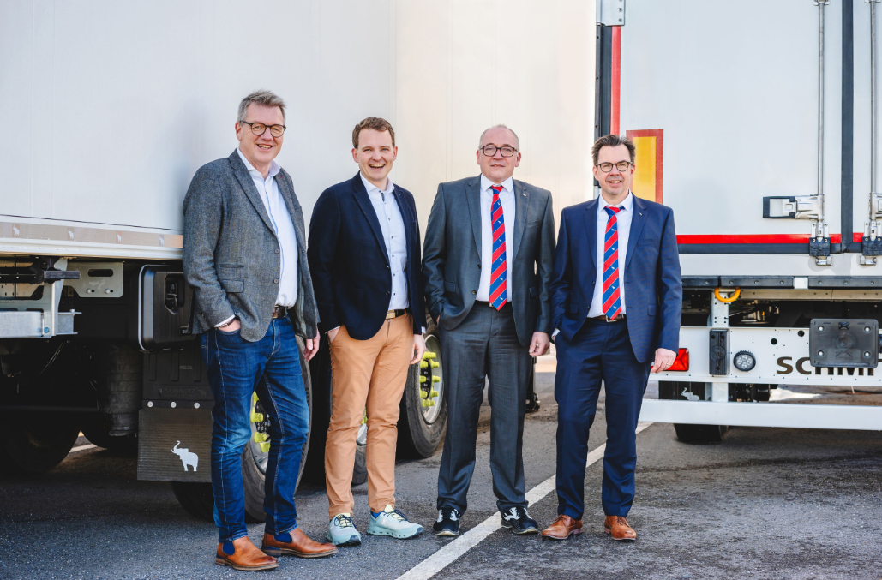

Caption:
Christian Glebe (Vreden Plant Director, right) and Michael Franek (Head of Production Technology at Schmitz Cargobull and expansion project lead, 3rd from left) welcomed Dr Tom Tenostendarp (Mayor of Vreden, 2nd from left) and Joachim Hartmann (Head of Urban Development, City of Vreden, left) to the factory in mid-January to showcase the building project in person.

About Schmitz Cargobull
Schmitz Cargobull is the leading manufacturer of semi-trailers for temperature-controlled freight, general cargo and bulk goods in Europe, and a pioneer in digital solutions for trailer services and improved connectivity. The company also manufactures transport cooling units for refrigerated box body semi-trailers for temperature-controlled freight transport. With a comprehensive range of services from financing, spare parts supply, service contracts and telematics solutions to used vehicle trading, Schmitz Cargobull supports its customers in optimising their total cost of ownership (TCO) and digital transformation. Schmitz Cargobull was founded in 1892 in Münsterland, Germany. The family-run company produces around 60,000 vehicles per year with over 6,000 employees, and generated a turnover of around €2.4 billion in the 2023/24 financial year. The international production network currently comprises ten plants in Germany, Lithuania, Spain, England, Turkey, Slovakia and Australia.

The Schmitz Cargobull press team:
Anna Stuhlmeier +49 2558 81-1340 I anna.stuhlmeier@cargobull.com
Andrea Beckonert +49 2558 81-1321 I andrea.beckonert@cargobull.com
Silke Hesener +49 2558 81-1501 I silke.hesener@cargobull.com

