**Press Release**

**2024-159**

**Maximum safety level guaranteed!   
S.KO COOL refrigerated box body semi-trailer from Schmitz Cargobull receives new TAPA TSR standard certification**

September 2024 – The new safety equipment for the Schmitz Cargobull S.KO COOL refrigerated box body semi-trailer has been awarded certification in accordance with the 2023 TAPA TSR1 standards, the highest level of the Transported Asset Protection Association Trucking Security Requirements (TAPA TSR). Representatives from Schmitz Cargobull, the TAPA organisation and the independent DQS testing institute came together for the official handover of the certificate at the IAA TRANSPORTATION in Hannover. This confirms that Schmitz Cargobull semi-trailers are now TAPA-ready for the latest 2023 edition of the TSR-1 standards.

“This exclusive level of security is only possible with the connectivity infrastructure included in Schmitz Cargobull’s TrailerConnect® telematics solution,” explains Volker Flatau, Head of the Cool Freight Product Line at Schmitz Cargobull. “We are pleased to be able to offer our customers a refrigerated box body semi-trailer equipped to the highest TAPA safety standards ex works and to contribute to greater supply chain security. And we will remain in close contact with the TAPA organisation over the next few years so that we can help shape future safety requirements. This will allow us to continue offering our customers the highest standards of safety at all times,” assured Carsten Krieger, Product Manager at Schmitz Cargobull.

**TAPA standard-compliant safety equipment**

In order to meet the high requirements for protecting high-value and sensitive goods during the transport process, an alarm and communication system networked with TrailerConnect® is integrated and triggers an audible alarm if someone attempts to open the trailer without authorisation. Furthermore, the electronic TL4 door locking system ensures that the freight is protected against access by unauthorised third

**2024-159**

parties. This is only possible with the networked TrailerConnect® telematics solution from Schmitz Cargobull.

Users can define loading and unloading locations in the TrailerConnect® portal where the door locking system automatically unlocks the trailer on arrival or locks it when leaving. Geofence-areas only need to be configured once, simply and conveniently in the TrailerConnect® portal. Furthermore, once the trailer door has been closed, a general automatic lock can be activated at the touch of a button in the TrailerConnect® portal or beSmart app.

The Transported Asset Protection Association (TAPA) is an organisation made up of manufacturers, logistics service providers, freight forwarders and law enforcement authorities that applies proven methods and procedures to improve the security of valuable assets around the world. Its goal is to reduce losses in the supply chain. The equipment was certified by Deutsche Gesellschaft zur Zertifizierung von Managementsystemen (DQS), an organisation that specialises in certifying management systems.

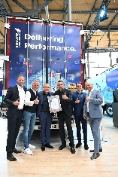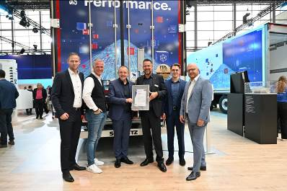

Caption: Handover of the certificate at the Schmitz Cargobull booth at the IAA TRANSPORTATION 2024 (from left): Philipp Ostendarp, Technical Project Manager for ECU & Sensors, Schmitz Cargobull, Markus Prinz, Senior Manager Standards, Transported Asset Protection Association (TAPA), Volker Flatau, Head of the Cool Freight Product Line, Schmitz Cargobull, Carsten Krieger, Product Manager for the S.KO Product Line, Schmitz Cargobull, Fabian van den Boom, Requirements Engineering, Schmitz Cargobull, Andreas Völkerding, Auditor, DQS

**About Schmitz Cargobull**

Schmitz Cargobull is the leading manufacturer of semi-trailers for temperature-controlled freight, general cargo and bulk goods in Europe, and a pioneer in digital solutions for trailer services and improved connectivity. The company also manufactures transport cooling units for refrigerated box body semi-trailers for temperature-controlled freight transport. With a comprehensive range of services from financing, spare parts supply, service contracts and telematics solutions to used vehicle trading, Schmitz Cargobull supports its customers in optimising their total cost of ownership (TCO) and digital transformation.

Schmitz Cargobull was founded in 1892 in Münsterland, Germany. The family-run company produces around 60,000 vehicles per year with over 6,000 employees, and generated a revenue of around €2.6 billion in the 2022/23 financial year. The international production network currently comprises ten plants in Germany, Lithuania, Spain, England, Turkey, Slovakia and Australia.

**The Schmitz Cargobull press team:**

Anna Stuhlmeier +49 2558 81-1340 I [anna.stuhlmeier@cargobull.com](mailto:anna.stuhlmeier@cargobull.com)

Andrea Beckonert +49 2558 81-1321 I [andrea.beckonert@cargobull.com](mailto:andrea.beckonert@cargobull.com)  
Silke Hesener +49 2558 81-1501 I [silke.hesener@cargobull.com](mailto:silke.hesener@cargobull.com)