Press Release
2025-107

Schmitz Cargobull AG
Schmitz Cargobull receives seal of approval for sustainable trailer telematics for the third time
The German Institute for Sustainability & Economy has once again honoured the Schmitz Cargobull subsidiary Cargobull Telematics GmbH in the areas of ecology, economy and social competence.

February 2025 - As in 2021 and 2023, the Schmitz Cargobull subsidiary Cargobull Telematics GmbH has been awarded the "Assured Sustainability" seal of approval by the German Institute for Sustainability & Economy this year.

The certificate confirms that the company acts in an exemplary manner in terms of sustainability and organises all processes in an economically sustainable manner. This includes the quality of products, services and advice, as well as ecological and social responsibility and future economic orientation. The individual sustainability competences in the areas of environment, energy, social affairs, economy and regionality were verified through on-site audits.

The TrailerConnect® telematics system also continues to be certified. Transport companies that use the TrailerConnect® system benefit from high sustainability and safety standards. Using high-quality sensors, important measured values such as temperature, tyre pressure, brake performance and axle load are continuously transmitted to a central platform and provide fleet managers with real-time information on the condition of the fleet. Controlled data exchange allows data to be shared with various parties along the supply chain. This contributes to the optimisation of routes and vehicle maintenance, helping to increase efficiency.

2025-107

Fleet operators can significantly improve their position in public tenders or audits, such as for ISO 14001 environmental management, ISO 50001 energy management or ISO 16247 energy audits, with a certified TrailerConnect® system. This also applies to consignors who require various proofs of a company's sustainability
of a company in order to award contracts.

With more than 20 years of experience in the development and marketing of its own TrailerConnect® telematics system, and over 110,000 currently active telematics units, Cargobull Telematics GmbH is setting standards on Europe’s roads. As a wholly owned subsidiary of Schmitz Cargobull AG, it is one of the leading providers of trailer telematics services and innovative digital products for the transport industry. In addition to developing its own hardware and software, Cargobull Telematics offers a comprehensive range of trailer telematics services. This includes consulting services in the area of data interface management as well as transport and fleet management processes. The services offered by Cargobull Telematics GmbH are individually tailored to the needs of customers and are available throughout Europe.

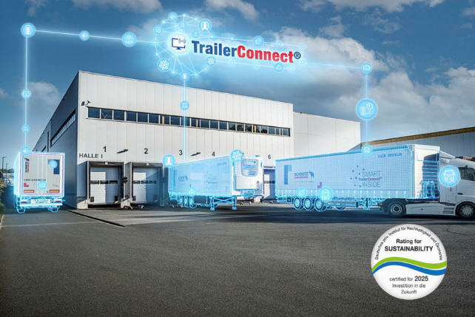

About Schmitz Cargobull
Schmitz Cargobull is the leading manufacturer of semi-trailers for temperature-controlled freight, general cargo and bulk goods in Europe, and a pioneer in digital solutions for trailer services and improved connectivity. The company also manufactures transport cooling units for refrigerated box body semi-trailers for temperature-controlled freight transport. With a comprehensive range of services from financing, spare parts supply, service contracts and telematics solutions to used vehicle trading, Schmitz Cargobull supports its customers in optimising their total cost of ownership (TCO) and digital transformation. Schmitz Cargobull was founded in 1892 in Münsterland, Germany. The family-run company produces around 60,000 vehicles per year with over 6,000 employees, and generated a turnover of around €2.4 billion in the 2023/24 financial year. The international production network currently comprises ten plants in Germany, Lithuania, Spain, England, Turkey, Slovakia and Australia.

The Schmitz Cargobull press team:
Anna Stuhlmeier +49 2558 81-1340 I anna.stuhlmeier@cargobull.com
Andrea Beckonert +49 2558 81-1321 I andrea.beckonert@cargobull.com
Silke Hesener +49 2558 81-1501 I silke.hesener@cargobull.com

