Press Release
2024-307

Schmitz Cargobull AG
BERGERecotrail® lightweight vehicles with TrailerConnect® telematics and services from Schmitz Cargobull
- A strong performance: BERGER ecoCOIL for up to 2.5 tonnes more payload

June 2024 – Customers have been able to purchase specialist lightweight BERGERecotrail® semi-trailers through the Schmitz Cargobull sales network since the start of the year. This also guarantees access to the Europe-wide supply of spare parts within the Schmitz Cargobull Service Partner network. Now, additional Schmitz Cargobull services are also available, including finance options, insurance and the TrailerConnect® telematics system installed in the trailer as standard.

The TrailerConnect® telematics system delivers real-time information on the condition of the vehicle and tyres, helping to improve safety as a result. On the whole, TrailerConnect® is an efficient way to monitor and manage the status of your trailer fleet.

Two of the main reasons why lightweight trailers are becoming increasingly relevant for transport firms are their ability to optimise payload and increase sustainability. Our lightweight BERGERecotrail® semi-trailers are particularly in high demand among customers looking for high payloads. Their reduced unladen weight not only lowers fuel consumption and wear, but also enables more freight to be transported.

BERGER ecoCOIL SAPL 24 LTCn – a total weight of just 5.3 tonnes for a 29.7 tonnes payload
The BERGERecoCOIL trailer has been specially designed to transport steel coils and is distinguished by its robust, lightweight steel structure and a sliding tarpaulin body with a coil-through design. The high-precision welded design – paired with premium components and comprehensive corrosion protection – ensures maximum safety and durability. Specifically designed for coil transport, the ecoCOIL can easily carry coils with a diameter between 800 mm and 2,100 mm thanks to its special loading surface concept.

2024-307

With a payload capacity of 29.7 tonnes, the vehicle is able to transport goods with up 2,500 kg added weight. The BERGER ecoCOIL is also equipped with the Schmitz Cargobull TrailerConnect® telematics system as standard to ensure efficient fleet management.
With lightweight BERGERecotrail® vehicles, transport companies also save on road tolls. A 2-axle BERGERecotrail® saves an impressive 2.4 cents per kilometre based on the new toll rates that came into effect on 1 December 2023. With an annual mileage of 120,000 kilometres, this results in a total toll saving of €2,880 per truck. This increases their cost-effectiveness and underpins profitability.

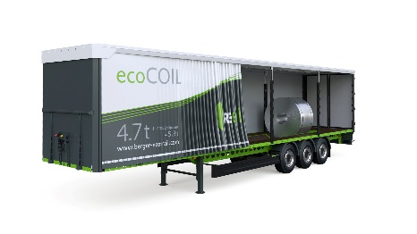
About Schmitz Cargobull
Schmitz Cargobull is the leading manufacturer of semi-trailers for temperature-controlled freight, general cargo and bulk goods in Europe, and a pioneer in digital solutions for trailer services and improved connectivity. The company also manufactures transport cooling units for refrigerated box body semi-trailers for temperature-controlled freight transport. With a comprehensive range of services from financing, spare parts supply, service contracts and telematics solutions to used vehicle trading, Schmitz Cargobull supports its customers in optimising their total cost of ownership (TCO) and digital transformation.
Schmitz Cargobull was founded in 1892 in Münsterland, Germany. The family-run company produces around 60,000 vehicles per year with over 6,000 employees, and generated a turnover of around €2.6 billion in the 2022/23 financial year. The international production network currently comprises ten plants in Germany, Lithuania, Spain, England, Turkey, Slovakia and Australia.

The Schmitz Cargobull press team:
Anna Stuhlmeier +49 2558 81-1340 I anna.stuhlmeier@cargobull.com
Andrea Beckonert +49 2558 81-1321 I andrea.beckonert@cargobull.com
Silke Hesener +49 2558 81-1501 I silke.hesener@cargobull.com

