Press Release
2024-170

Schmitz Cargobull AG
Schmitz Cargobull honoured with German Sustainability Award 2025
Market leader impresses in the Mobility and Logistics category

November 2024 – Schmitz Cargobull, the leading European trailer manufacturer, was honoured with the 2025 German Sustainability Award, in the Mobility and Logistics category for the automotive industry. The European market leader for semi-trailers won over a jury of experts with its effective and exemplary contributions to sustainable production processes as well as its product portfolio, which is designed for longevity and resource conservation. The award places Schmitz Cargobull as part of Germany’s 100 pioneers of transformation who are setting an important example in the sector.

On 28 November 2024, Andreas Schmitz, CEO of Schmitz Cargobull AG, accepted the award as part of the 17th German Sustainability Day at the MARITIM Hotel in Düsseldorf. The award was presented by Dr. Otto Schulz, Member of the Board German Sustainability Award Foundation.

“As a fourth-generation family business we regard sustainability as an integral part of our company strategy and as the origin of many in-house innovations. The challenges of sustainable transformation encourage us to create new innovations and give us food for thought. However, it is important for our customers and for us that the necessary sustainability measures are effective and economically viable and are not subject to overregulation,” explains Schmitz.
“We are proud to accept the German Sustainability Award for Companies in the Mobility and Logistics Category for the automotive industry. This award is proof that our team is well-positioned, hard-working, and has the necessary expertise to find innovative decarbonisation solutions. We would like to thank the jury, and everyone involved for this recognition. We will continue to make every effort to lead Schmitz Cargobull successfully and sustainably into the next generation.”

2024-170

The German Sustainability Award honours exemplary companies from 100 sectors that offer successful solutions for the challenges of sustainable transformation. The aim is to make these solutions widely available and drive forward transformation in the German economy. A total of 224 expert jurors from the fields of research, associations, consulting and civil society selected the 100 role models of change in all sectors of the German economy. The winners show especially effective, successful and exemplary contributions to transformation and make a joint effort in connecting all companies from one sector.
The CEOs and sustainability officers of the 100 pioneering companies, prominent speakers, and guests of honour from the world of economy, politics and society as well
as approx. 100 media representatives attended the event.

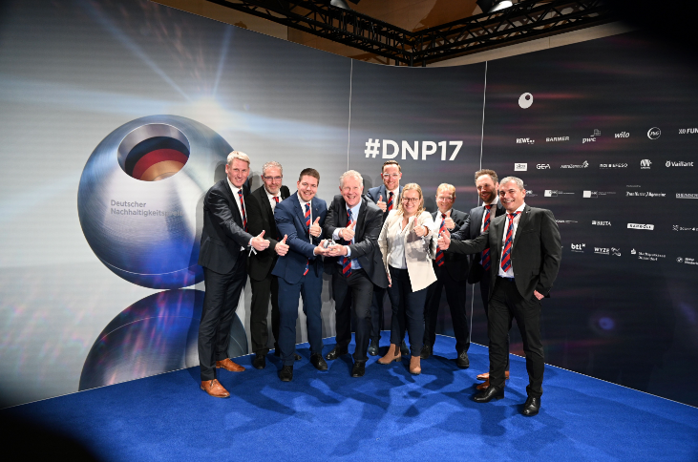
Caption 1: Andreas Schmitz and his team are delighted to receive this outstanding award.

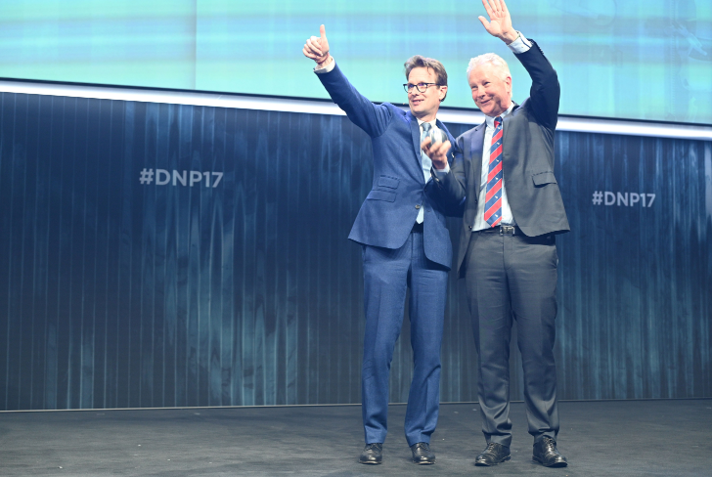
Caption 2: Presentation of the award to Andreas Schmitz (right) by Dr Otto Schulz (left), Member of the Board of the German Sustainability Award Foundation.

2024-170

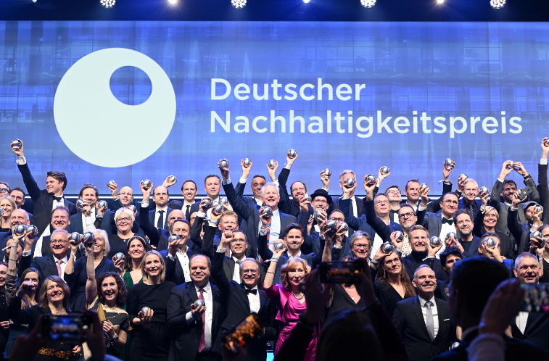
Caption 3: Group photo of the winners of the German Sustainability Award 2025.

About Schmitz Cargobull
Schmitz Cargobull is the leading manufacturer of semi-trailers for temperature-controlled freight, general cargo and bulk goods in Europe, and a pioneer in digital solutions for trailer services and improved connectivity. The company also manufactures transport cooling units for refrigerated box body semi-trailers for temperature-controlled freight transport. With a comprehensive range of services from financing, spare parts supply, service contracts and telematics solutions to used vehicle trading, Schmitz Cargobull supports its customers in optimising their total cost of ownership (TCO) and digital transformation. Schmitz Cargobull was founded in 1892 in Münsterland, Germany. The family-run company produces around 60,000 vehicles per year with over 6,000 employees and generated a turnover of around €2.4 billion in the 2023/24 financial year. The international production network currently comprises ten plants in Germany, Lithuania, Spain, England, Turkey, Slovakia and Australia.

The Schmitz Cargobull press team:
Anna Stuhlmeier +49 2558 81-1340 I anna.stuhlmeier@cargobull.com
Andrea Beckonert +49 2558 81-1321 I andrea.beckonert@cargobull.com
Silke Hesener +49 2558 81-1501 I silke.hesener@cargobull.com

