Press Release
2024-150

Schmitz Cargobull AG
Schmitz Cargobull invests in the logistics of the growing spare parts business
New narrow-aisle warehouse opened at the business’s main spare parts facility ; spare parts for Berger lightweight vehicles also now available

August 2024 - Schmitz Cargobull is investing in the expansion of its central warehouse for spare parts at Altenberge. This will ensure a high level of material availability for service partners and customers through improved utilisation at the site.

Schmitz Cargobull's European spare parts business has grown strongly in recent years.
In order to be able to offer fast and reliable delivery of more than 80,000 spare parts, the company is continuously expanding its range of services. With the new narrow-aisle warehouse more storage space for additional spare parts has been created. Spare parts for Berger lightweight vehicles will also be distributed from the site.

"Compared to independent dealers, Schmitz Cargobull offers a decisive advantage: one-stop shopping and parts identification via the chassis number in the EPOS spare parts portal, which enables fast repairs and high uptime for Schmitz Cargobull trailers," says Britta Sprey, Managing Director at Cargobull Parts & Services.

Expanded central warehouse
The new, manually operated narrow-aisle warehouse has eight aisles and a rack height of
14 metres. It offers around 3,300 pallet spaces and stores pallet cages, Euro pallets and half pallets. Different shelf heights optimise warehouse utilisation. The relocation of materials under the roof enables shorter routes in the warehouse, which improves process quality.
The improved material availability also leads to shorter delivery times, and further measures to increase and improve storage capacity are planned.

"We now have 29 distribution centres throughout Europe to ensure that we can supply our workshops and customers with the most common spare parts 24/7. The central warehouse
in Altenberge is used as a distribution centre for Germany and Austria. From here, we supply

2024-150

the international distribution centres several times a day or, if required, we can deliver directly to our service partners throughout Europe," explains Britta Sprey.

Since January 2023, Schmitz Cargobull has relied on 100% digital processes in the central warehouse - from delivery to loading. Employees work with back-of-hand and finger scanners as well as industrial tablets, which enables efficient and secure processes.

EPOS spare parts portal
The Schmitz Cargobull spare parts portal EPOS (Electronic Parts Documentation and Ordering System) is a comprehensive database with a selection of around 80,000 spare parts items. The platform offers service partners and customers with their own workshops everything they need for maintaining trailers and refrigeration units. It acts as a convenient "one-stop shop", providing access to all spare parts from Schmitz Cargobull and other brand manufacturers. All common components, chassis and wear parts are available from the Schmitz Cargobull central warehouse, and the 29 distribution centres in Europe. The EPOS portal now contains over 1.4 million documented vehicles. By entering the VIN (chassis number), the service partner can easily identify the required spare parts and order them via the web shop, regardless of opening hours or call centre availability.


Britta Sprey, Managing Director at Cargobull Parts & Services

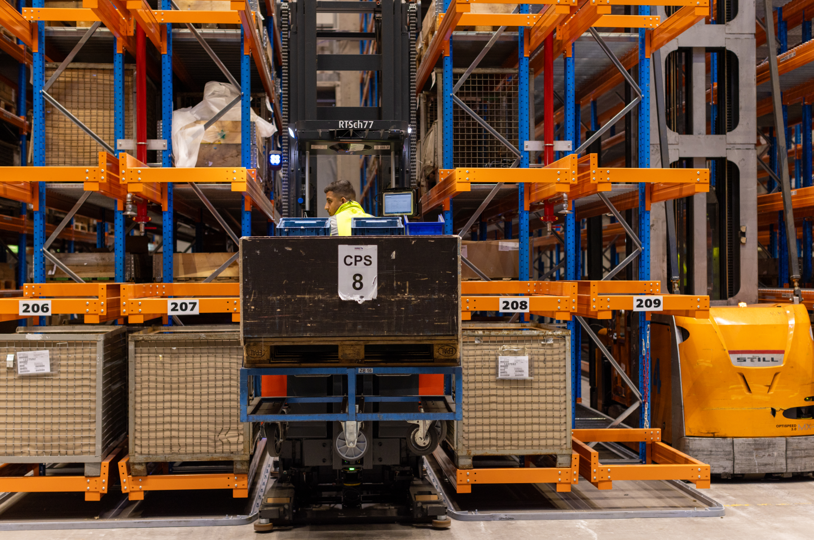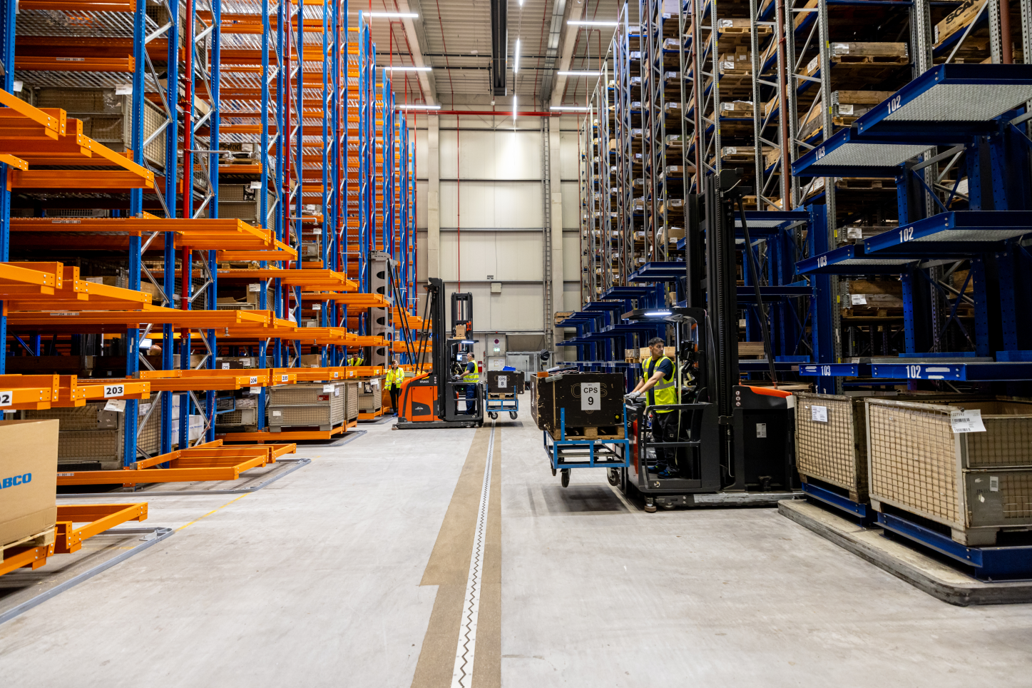

New narrow-aisle warehouse in the central warehouse for spare parts at the Altenberge site

2024-150

About Schmitz Cargobull
Schmitz Cargobull is the leading manufacturer of semi-trailers for temperature-controlled freight, general cargo and bulk goods in Europe and a pioneer in digital solutions for trailer services and improved connectivity. The company also manufactures transport refrigeration machines for refrigerated semi-trailers for temperature-controlled freight transport. With a comprehensive range of services from financing, spare parts supply, service contracts and telematics solutions to used vehicle trading, Schmitz Cargobull supports its customers in optimising their total cost of ownership (TCO) and digital transformation. Schmitz Cargobull was founded in 1892 in Münsterland, Germany. The family-run company produces
around 60,000 vehicles per year with over 6,000 employees and generated a turnover of around 2.6 billion euros in the 2022/23 financial year. The international production network currently comprises ten plants in Germany, Lithuania, Spain, England, Turkey, Slovakia and Australia.

The Schmitz Cargobull press team:
Anna Stuhlmeier +49 2558 81-1340 I anna.stuhlmeier@cargobull.com
Andrea Beckonert +49 2558 81-1321 I andrea.beckonert@cargobull.com
Silke Hesener +49 2558 81-1501 I silke.hesener@cargobull.com

