Press Release
2024-157

Schmitz Cargobull AG
Schmitz Cargobull impresses in ETM Verlag’s readers’ choice award
- Awards in five categories: tipper trailers, axles, trailer cooling, trailer telematics and “The future of logistics”

- BERGERecotrail, the latest member of the Schmitz Cargobull portfolio, wins in the “Light-weight semi-trailer” category

In September 2024, Schmitz Cargobull took home not one but five awards for the first time in the ETM publishing company’s much coveted Best Brand Awards, which are voted for by readers. More than 3,000 readers of FERNFAHRER and trans.aktuell magazines and users of the eurotransport.de portal took part in the vote. And they ended up awarding first place Schmitz Cargobull’s S.KI tipper semi-trailer with on-board weighing system, the TrailerConnect® telematics system, the S.CU transport cooling unit, the ROTOS® axle and the EcoDuo concept. In the “Light-weight semi-trailer” category, the BERGERecotrailer semi-trailer, which has been available through the Schmitz Cargobull sales network since early 2024, came out on top.

“The five awards presented to Schmitz Cargobull as part of this year’s readers’ choice award are particularly valuable for us as they come directly from the users of our products,” said Andreas Schmitz, Chairman of the Board of Schmitz Cargobull AG, at the awards ceremony held during the IAA TRANSPORTATION 2024 in Hannover on 19 September. “This recognition shows us that our products impress during day-to-day use and meet our customers’ high standards. We are particularly proud that our S.CU transport cooling unit was named as best cooling unit in the semi-trailer cooling category. This shows that the full package offered by Schmitz Cargobull for the area of temperature-controlled transport has been well received by customers. I’d like to say a huge thank you to our customers and the readers who voted for us and, of course, to the entire Schmitz Cargobull team, too. Successes like these are only possible with the commitment of every one of them.”

2024-157

Schmitz Cargobull also came out on top in the semi-trailer telematics and axles categories. “Schmitz Cargobull is a universal system provider with its TrailerConnect® telematics system and cooling unit,” Schmitz continued. “Every component is ideally tuned to our semi-trailers and work seamlessly together. This holistic approach has proven to be effective and extremely successful for our customers.”

The EcoDuo combination is ideally suited to combined transport and reduces the carbon emissions per tonne transported by road by more than 25 percent. The EcoDuo is starting a one-year pilot project in Germany in September 2024. The global logistics provider Sesé, which uses the EcoDuo for its regular operations in Spain, is driving the EcoDuo back and forth between the VW plant in Wolfsburg and a terminal in Lehrte.

The ETM Award is regarded as an important indicator and benchmark in the commercial vehicles sector. The ETM Verlag held its first ever reader vote back in 1997. In the 2024,
the motto for the coveted awards was “BEST OF NEW TRANSPORTATION”. The updated awards process covered the areas of “vehicles and trailers”, “suppliers and service providers” and “concepts”. This year, selected participants voted in 24 categories, with a specific product being the focus in most cases. Readers were able to choose from a total of 94 participants from the commercial vehicles sector, ranging from HGVs and transporters through to products, solutions and brands.

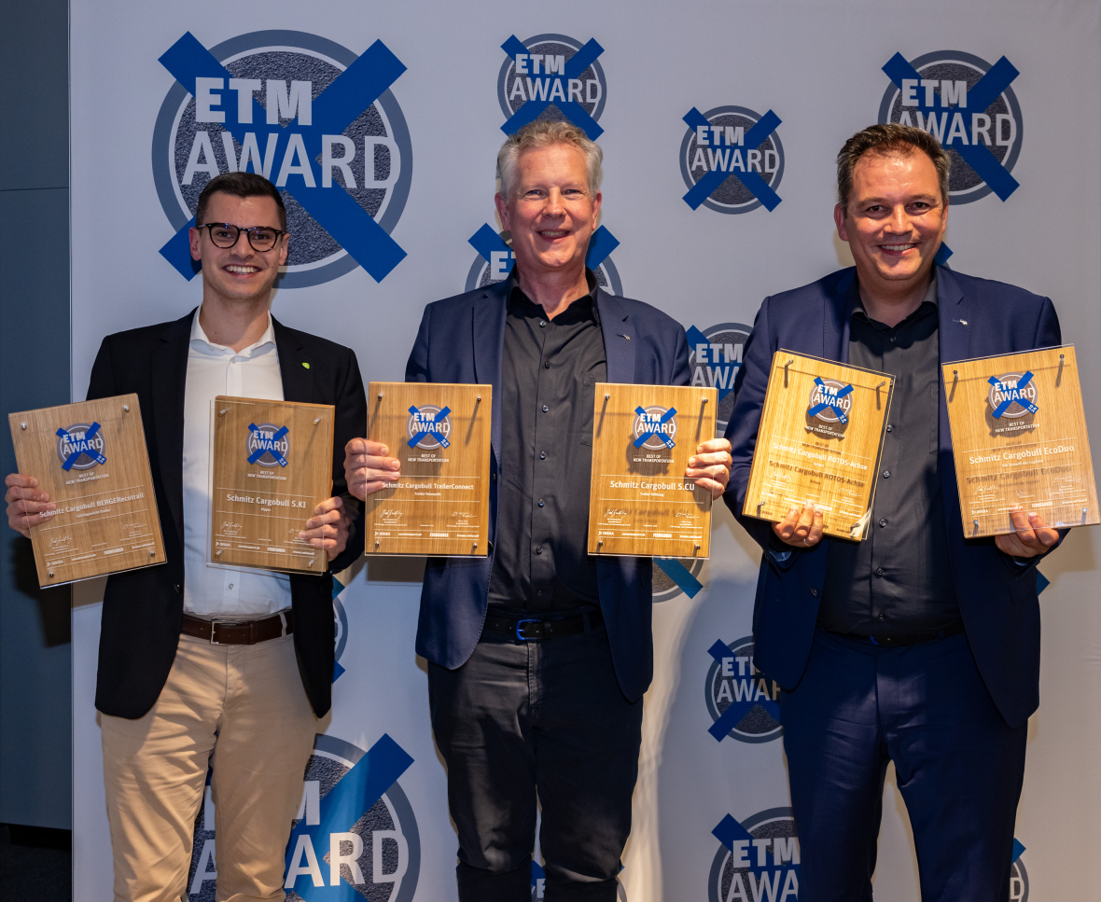

Caption: from left: Martin Krömer (Berger Fahrzeugtechnik GmbH), Andreas Schmitz (CEO Schmitz Cargobull) und Ralph Kleideiter (Sales Schmitz Cargobull)
Picture credits: ETM Verlag

2024-157

About Schmitz Cargobull
Schmitz Cargobull is the leading manufacturer of semi-trailers for temperature-controlled freight, general cargo and bulk goods in Europe, and a pioneer in digital solutions for trailer services and improved connectivity. The company also manufactures transport cooling units for refrigerated box body semi-trailers for temperature-controlled freight transport. With a comprehensive range of services from financing, spare parts supply, service contracts and telematics solutions to used vehicle trading, Schmitz Cargobull supports its customers in optimising their total cost of ownership (TCO) and digital transformation.
Schmitz Cargobull was founded in 1892 in Münsterland, Germany. The family-run company produces around 60,000 vehicles per year with more than 6,000 employees, and generated a turnover of around €2.6 billion in the 2022/23 financial year. The international production network currently comprises ten plants in Germany, Lithuania, Spain, England, Turkey, Slovakia and Australia.

The Schmitz Cargobull press team:
Anna Stuhlmeier +49 2558 81-1340 I anna.stuhlmeier@cargobull.com
Andrea Beckonert +49 2558 81-1321 I andrea.beckonert@cargobull.com
Silke Hesener +49 2558 81-1501 I silke.hesener@cargobull.com

