**Press Release**

**2024-161**

Schmitz Cargobull AG

**Schmitz Cargobull invests over 50 million euros in its Vreden site**

**The trailer manufacturer Schmitz Cargobull is reinforcing its commitment to its Vreden site and investing more than 50 million euros in expanding its production capacities for refrigerated and box body semi-trailers. The wide range of measures are aimed at further enhancing the company’s competitiveness.**

September 2024 – The investments are centred around the construction of a new 4,500 m² production hall, within which vehicle assembly will be completely restructured. Cutting-edge technology will be installed with a view to significantly increasing production capacity. According to current plans, the number of refrigerated vehicles produced per shift is due to be increased to 40, while the increased use of automation and digitalisation will reduce the cycle time per trailer from the current 15 minutes to just 10 minutes. This will result in a huge boost to efficiency and productivity at the Vreden site.

A central component of this project is the intensive use of digital tools to plan the new buildings and machinery. By doing so, the design of work processes can be optimised and the planned measures can be implemented in an efficient and future-proof way. For future production workflows, digital simulations will be used to test and validate the new processes at an early stage.

The Vreden site is also one of two flagship factories within the “Datenfabrik.NRW” promotional project, a regional project aimed at crafting data-based factories. As such, Schmitz Cargobull is taking on a pioneering role in the development of digital factories in the local area and creating a new benchmark for digital transformation within the industry.

**2024-161**

In addition to the new production hall, a new logistics concept will also be introduced to refine internal workflows. What’s more, measures will be taken to gradually upgrade components production to make the Vreden site more future-proof. All of the main measures will be implemented at the main refrigerated vehicle production plant in Südlohner Diek.

In addition to expanding production capacity, the existing supply centre at the Große Mast site will be increased. The existing parking capacity is due to be doubled by expanding into a neighbouring brownfield site, which will accelerate and optimise the vehicle delivery process. By ceasing to rent external parking areas in the local area, this measure will also reduce strain on local traffic and cut costs. The increased use of electrically powered tractor units will further increase the efficiency and sustainability of logistics processes.

With the measures taken, Schmitz Cargobull is making an important contribution to the achievement of in-house environmental objectives and actively helping to improve ecological and economical sustainability.

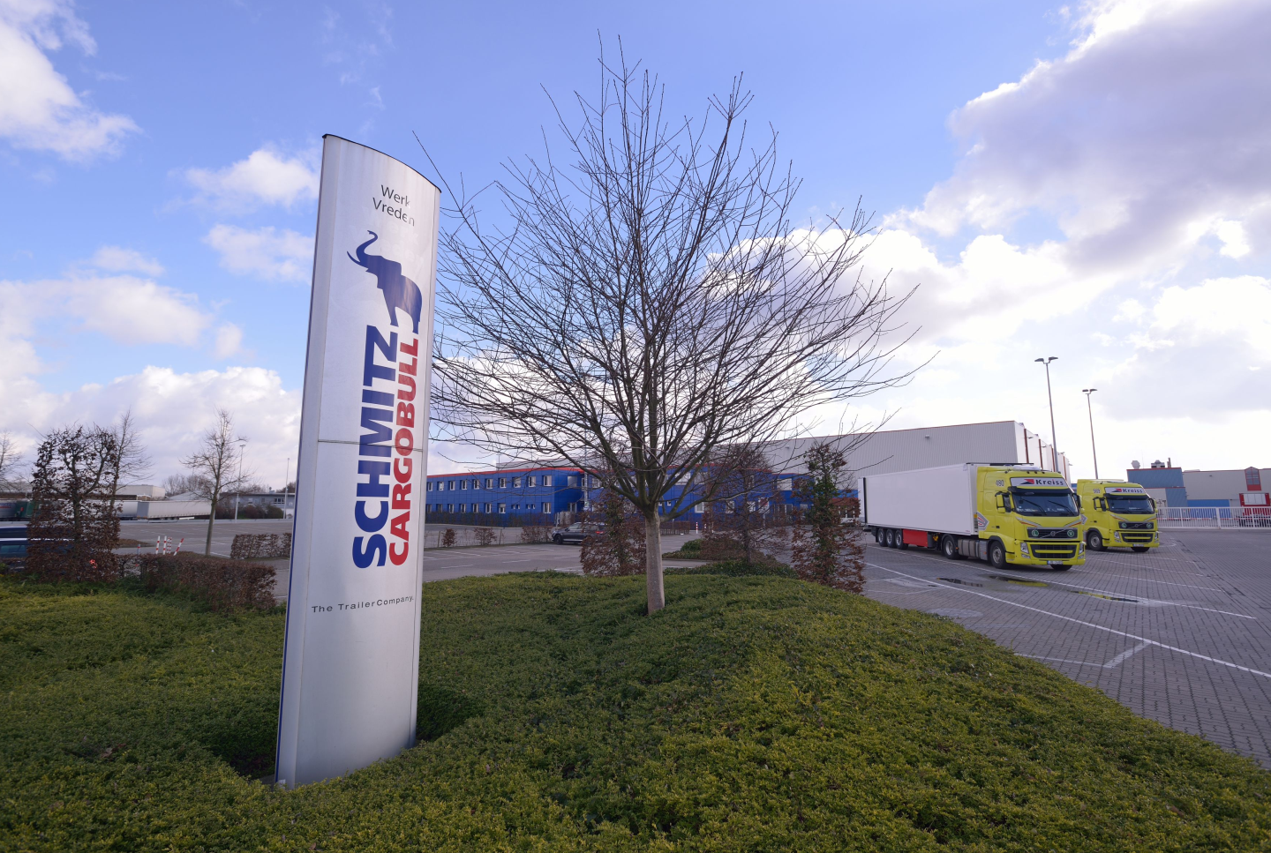

**2024-161**

**About Schmitz Cargobull**

Schmitz Cargobull is the leading manufacturer of semi-trailers for temperature-controlled freight, general cargo and bulk goods in Europe, and a pioneer in digital solutions for trailer services and improved connectivity. The company also manufactures transport cooling units for refrigerated box body semi-trailers for temperature-controlled freight transport. With a comprehensive range of services from financing, spare parts supply, service contracts and telematics solutions to used vehicle trading, Schmitz Cargobull supports its customers in optimising their total cost of ownership (TCO) and digital transformation.

Schmitz Cargobull was founded in 1892 in Münsterland, Germany. The family-run company produces around 60,000 vehicles per year with over 6,000 employees, and generated a turnover of around €2.4 billion in the 2023/24 financial year. The international production network currently comprises ten plants in Germany, Lithuania, Spain, England, Turkey, Slovakia and Australia.

**The Schmitz Cargobull press team:**

Anna Stuhlmeier +49 2558 81-1340 I [anna.stuhlmeier@cargobull.com](mailto:anna.stuhlmeier@cargobull.com)

Andrea Beckonert +49 2558 81-1321 I [andrea.beckonert@cargobull.com](mailto:andrea.beckonert@cargobull.com)  
Silke Hesener +49 2558 81-1501 I [silke.hesener@cargobull.com](mailto:silke.hesener@cargobull.com)