Press Release
2025-114

Schmitz Cargobull AG
Nationwide Produce grows fleet with new Schmitz Cargobull reefers

February 2025 - Fresh food supplier Nationwide Produce has returned to Schmitz Cargobull for seven S.KO COOL refrigerated semi-trailers to feed its growing business. The box-body trailers, each sitting on a fully galvanised MODULOS chassis with a 10-year warranty against rust-through, feature FERROPLAST® panels. These are stronger yet thinner than glass-reinforced plastic bodywork equivalents – boosting strength but reducing weight.

David Flinders, Group Transport Manager at Nationwide Produce, says: “We went with Schmitz Cargobull again because their trailers give us the best payload – up to 26 tonnes, as and when we need to use it. Despite being lighter than competitors’ trailers, they are also extremely strong.”

Schmitz Cargobull’s proven FERROPLAST® technology combines the increased insulation of a polyurethane hard foam with a durable and resistant covering of multiple layers of coated metal.

The result is a self-supporting product without any thermal bridges that may affect cooling performance. Another advantage that FERROPLAST® has compared with fibreglass walls is its vapour diffusion-tight metal covering. This prevents the absorption of efficiency-decreasing moisture and protects it against the accumulation of additional weight. Consequently, less time and energy are required to reach the essential level of refrigeration. The trailer’s temperature can also be maintained for a longer period, resulting in lower operating costs.

If any damage does occur, the panels can be easily repaired rather than the trailer side requiring whole body repair.

2025-114

“Having FERROPLAST® panels is useful because we deliver to and collect from a lot of tight places. If something does happen, we can get the repairs done quickly with minimum fuss at a Schmitz Cargobull Service Partner,” says Flinders.

Limiting downtime is important for a business that prides itself on prompt delivery nationwide, often next day and always within the specified one-hour slot. The new trailers, four of which feature Dhollandia tail-lifts, are based at the family-owned firm’s depots in Evesham and Spalding. A short time from manufacture to delivery meant Nationwide Produce avoided hiring additional trailers for the busy period.

The new tri-axle trailers with Thermo King refrigeration units are being used for multi-drop operations, delivering to locations including RDCs, wholesaler and food processors’ premises, and retail customers. Once deliveries are completed, the trailers collect produce from growers to restock Nationwide Produce’s depots ready for sale the next day.

Schmitz Cargobull’s TrailerConnect® telematics is fitted as standard on the trailers, providing 24/7 monitoring of the trailer’s exact location, plus vital data such as the interior temperature. The operator is also making full use of the newly introduced ability to connect Schmitz Cargobull’s telematics with Webfleet management software straight out of the factory gate.

Most of Nationwide Produce’s approximately 60 trailers feature the blue elephant logo on them, and the relationship has gone from strength to strength since the supplier’s decision to set up its own in-house transport in 2019.

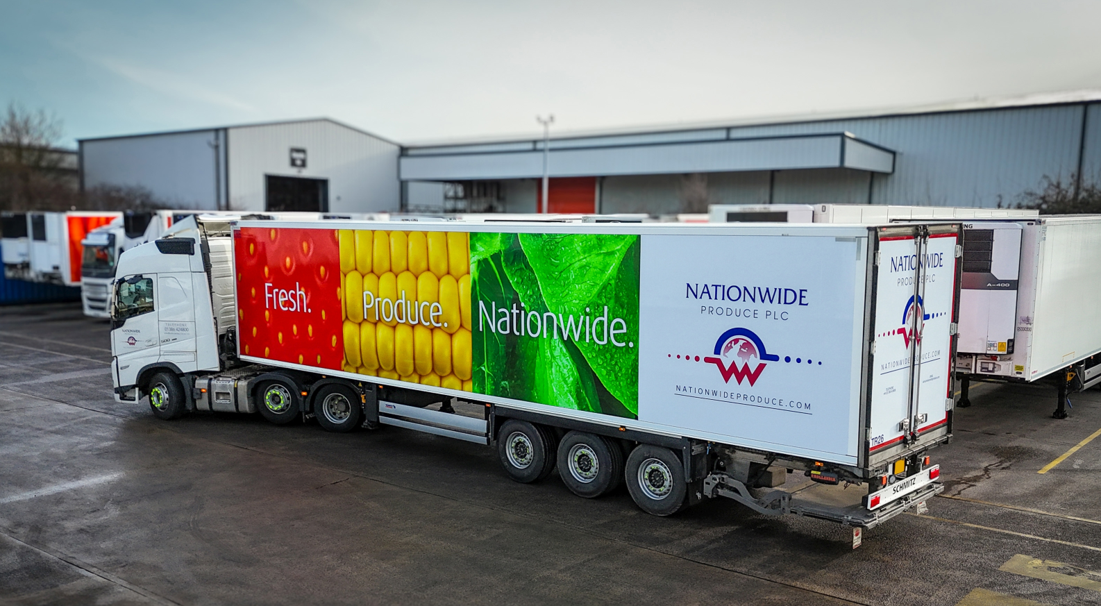

2025-114

About Nationwide Produce
Founded in Southport in 1975, Nationwide Produce PLC began as a local produce merchant and has grown into one of the UK’s largest, most established, and diverse companies in fresh produce. Serving food service, catering, processing, wholesale, export, and retail sectors, it provides a full range of vegetables, fruit, and exotic produce from around the world every day. With strong relationships across its supply base, Nationwide Produce bridges the gap between farmers and foodservice companies, delivering high-quality, fresh produce to over 1,000 customers throughout Europe daily.

About Schmitz Cargobull
Schmitz Cargobull is the leading manufacturer of semi-trailers for temperature-controlled freight, general cargo and bulk goods in Europe, and a pioneer in digital solutions for trailer services and improved connectivity. The company also manufactures transport cooling units for refrigerated box body semi-trailers for temperature-controlled freight transport. With a comprehensive range of services from financing, spare parts supply, service contracts and telematics solutions to used vehicle trading, Schmitz Cargobull supports its customers in optimising their total cost of ownership (TCO) and digital transformation. Schmitz Cargobull was founded in 1892 in Münsterland, Germany. The family-run company produces around 60,000 vehicles per year with over 6,000 employees and generated a turnover of around €2.4 billion in the 2023/24 financial year. The international production network currently comprises ten plants in Germany, Lithuania, Spain, England, Turkey, Slovakia and Australia.

The Schmitz Cargobull press team:
Anna Stuhlmeier +49 2558 81-1340 I anna.stuhlmeier@cargobull.com
Andrea Beckonert +49 2558 81-1321 I andrea.beckonert@cargobull.com
Silke Hesener +49 2558 81-1501 I silke.hesener@cargobull.com

