Press Release
2024-131

Schmitz Cargobull AG
Schmitz Cargobull S.KI tipper semi-trailer is named "Product of the Year”
Readers of the construction trade magazine Baugewerbe choose the S.KI tipper semi-trailer, with onboard weighing system, as the winner in the commercial vehicle category
May 2024 - The S.KI tipper semi-trailer with its new generation frame and rounded steel body has been named Product of the Year by readers of Baugewerbe magazine.
The S.KI tipper, which impresses with its improved payload capacity of up to 280 kilograms (50kg chassis, 180kg body, 50kg frame), came out on top in the commercial vehicle category. An optional onboard weighing system is available for the semi-trailer, allowing the driver to determine and document the vehicle's payload at the loading point. This helps to avoid overloading, meaning the vehicle and roads are exposed to less wear and tear, fuel costs are saved, and CO2 emissions are reduced.
Alexander Teleki, Head of Product Line Construction & Agriculture, and Kristin Hobert, Product Manager Product Line Construction & Agriculture, accepted the prize yesterday at the award ceremony at Coreum, in Stockstadt. The award was presented by Kai Link, Editor-in-Chief of Baugewerbe.
"This prize means a lot to us, as it is awarded by the readers, who are the practical users of our vehicles," says Alexander Teleki. "The award is a confirmation of our customer-orientated products and services. It motivates the entire team, which is always working on reliable and economical solutions for our customers. Our thanks go to all readers who voted in favour of the Schmitz Cargobull brand."
The "Product of the Year" readers' poll entered its third round this year. Products and projects from the construction industry were honoured in a total of 11 categories.

2024-131

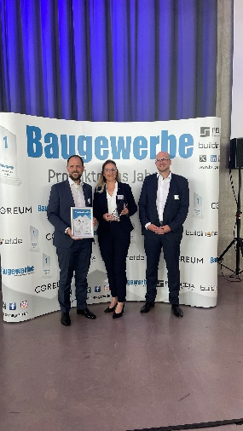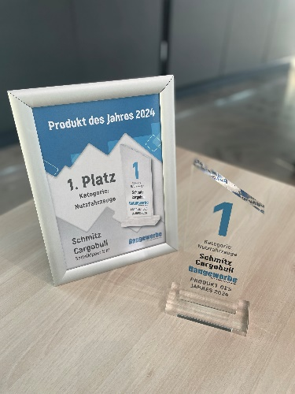
Caption: Delighted with first place: from left: Alexander Teleki, Head of Product Line Construction & Agriculture and Kristin Hobert, Product Manager Product Line Construction & Agriculture (both Schmitz Cargobull) join Kai Link, Editor-in-Chief Baugewerbe.
About Schmitz Cargobull
Schmitz Cargobull is the leading manufacturer of semi-trailers for temperature-controlled freight, general cargo and bulk goods in Europe and a pioneer in digital solutions for trailer services and improved connectivity. The company also manufactures transport refrigeration machines for refrigerated semi-trailers for temperature-controlled freight transport. With a comprehensive range of services from financing, spare parts supply, service contracts and telematics solutions to used vehicle trading, Schmitz Cargobull supports its customers in optimising their total cost of ownership (TCO) and digital transformation. Schmitz Cargobull was founded in 1892 in Münsterland, Germany. The family-run company produces
around 60,000 vehicles per year with over 6,000 employees and generated a turnover of around 2.6 billion euros in the 2022/23 financial year. The international production network currently comprises ten plants in Germany, Lithuania, Spain, England, Turkey, Slovakia and Australia.

The Schmitz Cargobull press team:
Anna Stuhlmeier +49 2558 81-1340 I anna.stuhlmeier@cargobull.com
Andrea Beckonert +49 2558 81-1321 I andrea.beckonert@cargobull.com
Silke Hesener +49 2558 81-1501 I silke.hesener@cargobull.com

