Press-Information
2025-119

Schmitz Cargobull AG
GT Trailers and Schmitz Cargobull AG sign strategic partnership

March 2025 – GT Trailers, a major producer of high-volume sets and trailers from the Opole region, in Poland, has signed an agreement with Schmitz Cargobull AG that will see Europe’s leading manufacturer of semi-trailers, trailers and bodies, from Münsterland, Germany, acquire a 48 per cent share in the business. The two companies intend to bring together their expertise in designing and building superstructures on rigid chassis, including tarpaulin, boxes, and refrigerated solutions. The transaction is subject to approval by the relevant competition authorities.

“Schmitz Cargobull and GT Trailers are both family businesses, with a reputation for reliability and longevity in the industry. Not surprisingly, because both companies offer galvanised chassis and bodies with anodised aluminum. By merging our innovation efforts and collaborating in sales we expect to increase the market share in the segment of high-volume combinations,” explains Andreas Schmitz, CEO of Schmitz Cargobull. “At Schmitz Cargobull, we firmly believe that cooperation and strategic partnerships are key drivers of innovation and growth.”

Agata Duliniec, CEO of GT Trailers, says: “With our strong commitment to quality and sustainability, GT Trailers has become a trusted name in the transport industry. The cooperation with Schmitz Cargobull will position us for continued success in the years ahead. Through this partnership we pave the way for innovation in products, services and market development.”

Both companies note that the transaction is subject to approval by the relevant competition authorities. GT Trailers and Schmitz Cargobull are confident, however, that the partnership will take effect shortly and are convinced that the cooperation will have positive effects for their customers.

2025-119



Agata Duliniec, CEO of GT Trailers Andreas Schmitz_CEO of Schmitz Cargobull

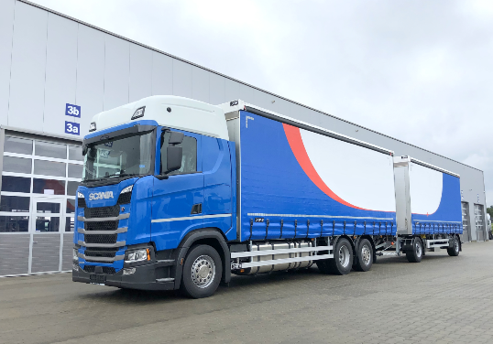
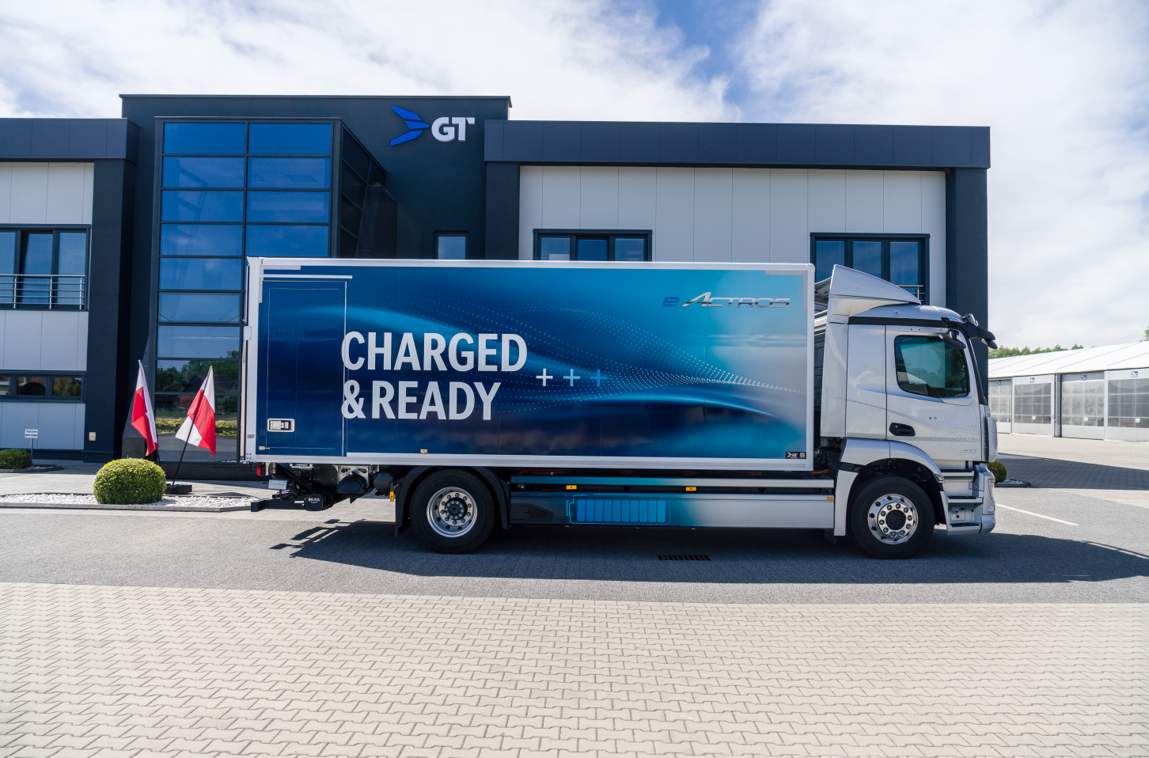
Box body on eActros Volume truck body and trailer

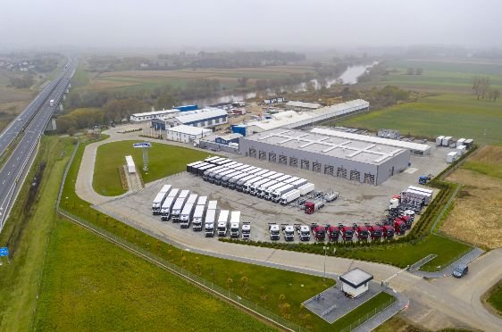
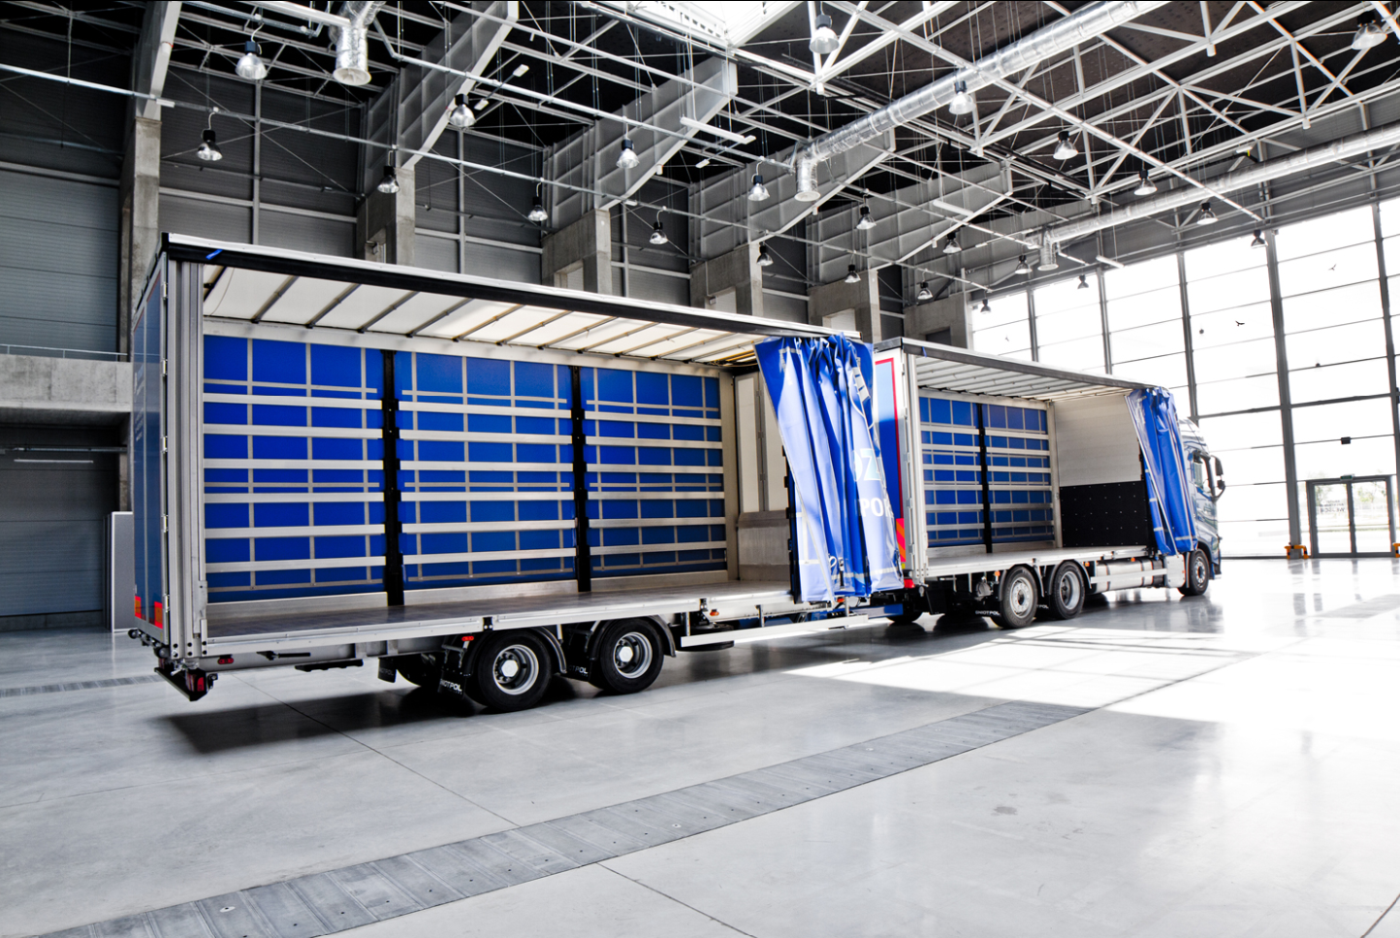
Volume truck body and trailer_open Production site in Malnia_Poland

About Schmitz Cargobull
Schmitz Cargobull is the leading manufacturer of semi-trailers for temperature-controlled freight, general cargo and bulk goods in Europe, and a pioneer in digital solutions for trailer services and improved connectivity. The company also manufactures transport cooling units for refrigerated box body semi-trailers for temperature-controlled freight transport. With a comprehensive range of services from financing, spare parts supply, service contracts and telematics solutions to used vehicle trading, Schmitz Cargobull supports its customers in optimising their total cost of ownership (TCO) and digital transformation. Schmitz Cargobull was founded in 1892 in Münsterland, Germany. The family-run company produces around 60,000 vehicles per year with over 6,000 employees, and generated a turnover of around €2.6 billion in the 2022/23 financial year. The international production network currently comprises ten plants in Germany, Lithuania, Spain, England, Turkey, Slovakia and Australia.

About GT Trailers:
GT Trailers is a polish manufacturer of high-volume transport solutions, specializing in high-volume sets, BDF swap body systems, and customised vehicle bodies tailored to individual customer needs. The company places a strong emphasis on quality and innovation, utiliing patented technologies and certified materials from renowned suppliers. As a result, GT Trailers’ vehicles stand out with their modern design and high durability, helping customers improve transport efficiency and reduce the total cost of ownership (TCO).
Founded in 1989 in Poland, GT Trailers is a family-owned company with a growing international presence. Its headquarters and production facilities are located in the Opole region, where the company manufactures up to 2,000 vehicles annually for the European market. Through consistent development and a strong focus on customer relationships, GT Trailers strengthens its position as an industry leader by offering transport solutions tailored to individual customer needs, further solidifying its role as a key player in the high-volume transport sector.

Press Contact Schmitz Cargobull
Anna Stuhlmeier +49 2558 81-1340 I anna.stuhlmeier@cargobull.com
Andrea Beckonert +49 2558 81-1321 I andrea.beckonert@cargobull.com
Silke Hesener +49 2558 81-1501 I silke.hesener@cargobull.com

