Press Release
2025-304

Schmitz Cargobull AG
Innovation meets sustainability
The new lightweight ecoCHAMP LTO curtainsider semi-trailer by BERGERecotrail® for maximum payload reduces journeys by up to 10 percent and is also ideally suited for use with e-tractor units.

February 2025 – The lightweight BERGERecotrail® curtainsider semi-trailer is particularly suited to transport jobs requiring a high payload and is regarded as the lightest vehicle on the market. With an unladen weight starting from 4.7 tonnes, the ecoCHAMP is a true all-rounder in the lighter vehicle market. An enhanced version with a shorter wheelbase has now been developed to maximise payload without overloading the tractor unit’s drive axle. Thanks to its high payload, the new ecoCHAMP LTO reduces the number of journeys by up to 10 per cent, and it is also ideal for use in combination with an electrically powered tractor unit (e-tractor unit).

High load capacities, a low unladen weight and high payloads are all key attributes of efficient vehicle solutions in the commercial vehicles sector and are also particularly relevant when it comes reducing carbon emissions. Lightweight trailers play a major role as they can optimise the payload, thus facilitating a higher load capacity. This in turn contributes to greater sustainability as fewer journeys are needed while transport volumes remain the same. The lower unladen weight not only reduces fuel consumption but also decreases wear and tear on the vehicle.
However, in day-to-day transport operations, tractor units’ drive axles are frequently overloaded, particularly when heavier e-tractor units are used. To resolve this challenge, the three axles on the new ecoCHAMP LTO have been repositioned and the wheelbase has been reduced while still observing the defined turning circle. As a result, less strain is placed on the curtainsider’s kingpin and the tractor unit’s drive axle so that, in practice, more goods can be transported without overloading occurring. This is particularly important when trying to exploit the full payload, e.g. when transporting beverages and timber loads, and when using e-tractor units.

2025-304

The ecoCHAMP LTO impresses with its unladen weight, whichhas been reduced by
1.5 tonnes. Like all BERGERecotrail® vehicles, it has been produced with a special lightweight design, which uses the Reuleaux triangle as a characteristic of its cutting-edge technology. The Reuleaux triangle enables a great deal of material to be removed from the l-beam without adversely affecting the strength and stability. This also minimises the vehicles’ unladen weight and maximises the payload.

The ecoCHAMP LTO trailer is certified for transporting beverages (a single layer of beverage crates on pallets plus kegs) and piece goods in accordance with DIN EN 12642 Code XL, DIN EN 12195-1 and VDI 2700 for maximum payload. An interlocking vehicle restraint system allows loading and unloading times to be cut and efficiency to be increased.

The vehicle can also be equipped with an optional POWER CURTAIN from Schmitz Cargobull. The POWER CURTAIN is particularly good at catering to turnover speed and efficiency requirements. The certified structural rigidity (according to DIN EN 12642 Code XL) is achieved even without support laths thanks to vertical and horizontal reinforcements, and a standard anti-theft protection fabric. As a result, the vehicle can be loaded and unloaded quickly and easily without extended handling processes. This increases transport efficiency and occupational safety, meaning the driver can continue their journey quicker and further optimise the transport process.
Customers have been able to purchase special lightweight BERGERecotrail® semi-trailers through the Schmitz Cargobull sales network since early 2024. Access to comprehensive, Europe-wide spare parts supply through the Schmitz Cargobull Service Partner network and the use of additional Schmitz Cargobull services, such as financing, insurance and standard use of TrailerConnect® telematics, including a tyre pressure management system with auto-location function, are also guaranteed. TrailerConnect® delivers real-time information on the condition of the vehicle and tyres, helping to improve safety and transparency in fleet management as a result.

2025-304

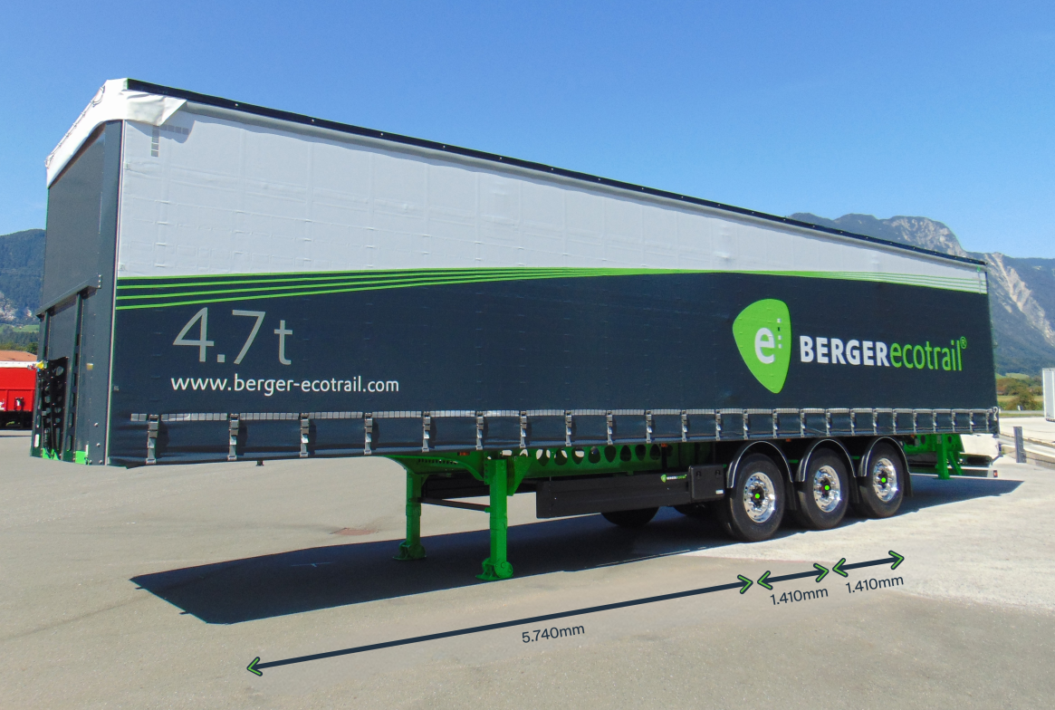

About Schmitz Cargobull
Schmitz Cargobull is the leading manufacturer of semi-trailers for temperature-controlled freight, general cargo and bulk goods in Europe, and a pioneer in digital solutions for trailer services and improved connectivity. The company also manufactures transport cooling units for refrigerated box body semi-trailers for temperature-controlled freight transport. With a comprehensive range of services from financing, spare parts supply, service contracts and telematics solutions to used vehicle trading, Schmitz Cargobull supports its customers in optimising their total cost of ownership (TCO) and digital transformation. Schmitz Cargobull was founded in 1892 in Münsterland, Germany. The family-run company produces around 60,000 vehicles per year with over 6,000 employees and generated a turnover of around €2.4 billion in the 2023/24 financial year. The international production network currently comprises ten plants in Germany, Lithuania, Spain, England, Turkey, Slovakia and Australia.

The Schmitz Cargobull press team:
Anna Stuhlmeier +49 2558 81-1340 I anna.stuhlmeier@cargobull.com
Andrea Beckonert +49 2558 81-1321 I andrea.beckonert@cargobull.com
Silke Hesener +49 2558 81-1501 I silke.hesener@cargobull.com

