**Press Release**

**2024-163**

Schmitz Cargobull AG

**Furgo-Trayler acquires 25 EcoDuo vehicle**

**combinations from Schmitz Cargobull**

**November 2024 - The Spanish parcel specialist Furgo-Trayler, which operates nationally and internationally, is adding 25 Schmitz Cargobull EcoDuo combinations to its fleet. These combinations consist of 50 S.BO EXPRESS dry freight semi-trailers and 25 dollies. In Spain, the EcoDuo vehicle combination, which comprises two standard semi-trailers connected via a dolly and pulled by a tractor unit, was authorised to run at 72 tonnes on the country’s roads at the beginning of 2014. This strategic investment should enable Furgo-Trayler to realise significant sustainability benefits, such as fuel savings and reduced CO2 emissions.   
The EcoDuo vehicles will also optimise logistics processes, allowing Furgo-Trayler to offer its customers a first-class service.**

Joan Monzón, CEO of Furgo-Trayler, is very pleased with the new acquisition. The reliability, safety and robustness of the Schmitz Cargobull trailers, which fit perfectly with Furgo-Trayler's growth and consolidation strategy in the transport sector, were decisive factors in the purchase decision. He emphasises that this investment is part of its internal EcoTrailer programme, which will challenge Furgo-Trayler to reduce its environmental footprint by 30 percent over the next five years. For the transformation to succeed, Monzón believes that investment and collaboration are vital to make the transport sector more environmentally friendly for drivers.

The new S.BO EXPRESS dry freight semi-trailers expand Furgo-Trayler's fleet, which comprises 623 semi-trailers. 50 per cent of them bear the blue elephant, the trademark of Schmitz Cargobull and main supplier of the Catalan company.

The S.BO EXPRESS dry freight semi-trailers, certified in accordance with DIN EN 12642 XL, are equipped with a double-decker system that enables a loading capacity of up to 66 Euro pallets. The vehicles are equipped with the TrailerConnect® telematics system and LED interior lighting as standard. The galvanised MODULOS chassis is easy to

**2024-163**

maintain, offers a high level of corrosion protection and has a 10-year guarantee against rusting through, which underlines the quality and durability of Schmitz Cargobull products.

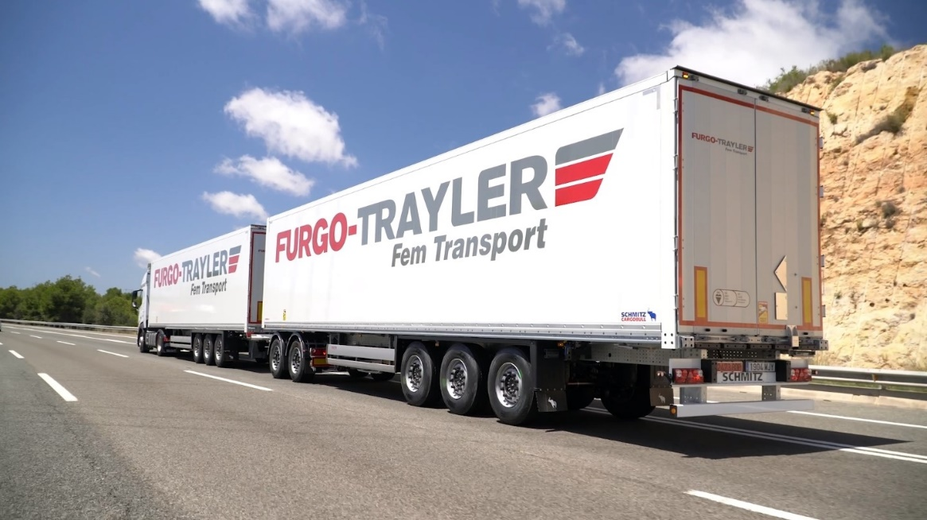

**About Schmitz Cargobull**

Schmitz Cargobull is the leading manufacturer of semi-trailers for temperature-controlled freight, general cargo and bulk goods in Europe, and a pioneer in digital solutions for trailer services and improved connectivity. The company also manufactures transport cooling units for refrigerated box body semi-trailers for temperature-controlled freight transport. With a comprehensive range of services from financing, spare parts supply, service contracts and telematics solutions to used vehicle trading, Schmitz Cargobull supports its customers in optimising their total cost of ownership (TCO) and digital transformation.

Schmitz Cargobull was founded in 1892 in Münsterland, Germany. The family-run company produces around 60,000 vehicles per year with over 6,000 employees and generated a turnover of around €2.4 billion in the 2023/24 financial year. The international production network currently comprises ten plants in Germany, Lithuania, Spain, England, Turkey, Slovakia and Australia.

**The Schmitz Cargobull press team:**

Anna Stuhlmeier +49 2558 81-1340 I [anna.stuhlmeier@cargobull.com](mailto:anna.stuhlmeier@cargobull.com)

Andrea Beckonert +49 2558 81-1321 I [andrea.beckonert@cargobull.com](mailto:andrea.beckonert@cargobull.com)  
Silke Hesener +49 2558 81-1501 I [silke.hesener@cargobull.com](mailto:silke.hesener@cargobull.com)