Press-Information
2024-142

Schmitz Cargobull AG
TOP 100 Award: Ranga Yogeshwar honours Schmitz Cargobull for innovative achievements
July 2024 - Recognition at the German SME Summit: Respected science journalist Ranga Yogeshwar congratulated Schmitz Cargobull AG, from Horstmar, on being awarded the TOP 100 seal. The award ceremony at the Summit took place on Friday 28 June, in Weimar, for all SMEs that received the TOP 100 seal at the beginning of the year. Yogeshwar is mentoring the innovation competition, which is being organised for the 31st time. In the scientific selection process, Schmitz Cargobull was particularly convincing in size category C (over 200 employees) in the "Innovative processes and organisation" category.
The systematic anchoring of innovation in the company was highlighted as a particular strength. This requires appropriate structures for the implementation of innovation processes and the promotion of an innovative corporate culture at all levels.
Schmitz Cargobull, the leading manufacturer of semi-trailers for temperature-controlled freight, general cargo and bulk goods in Europe, has been relying on the "Kaizen" model for decades - a business philosophy aimed at continuous improvement throughout the entire organisation. The driving force behind many innovations is the Innovation Circle, in which managers from research and development meet with the Executive Board and the technically orientated Supervisory Board members. R&D, pre-development, product line and sales work closely together to realise the projects. Many innovation successes at Schmitz Cargobull develop from the area of telematics and digital networking or increased sustainability. The all-electric S.KOe COOL was cited as an example of this. Schmitz Cargobull was the first OEM to receive type approval for the emission-free refrigerated reefer semi-trailer with an electric generator axle. The e-axle feeds additional energy into the battery of the refrigeration machine while travelling, so that food can be safely cooled and transported from the hub to the supermarket without emissions.
Click here for more information: www.top100.de/die-top-innovatoren.

2024-142
TOP 100: the competition
Since 1993, compamedia has been awarding the TOP 100 seal for special innovative strength and above-average innovation success to medium-sized companies. Prof Dr Nikolaus Franke has been the scientific director since 2002. Mr Franke is the founder and director of the Institute for Entrepreneurship and Innovation at the Vienna University of Economics and Business. The mentor of TOP 100 is the science journalist Ranga Yogeshwar. Project partners are the Fraunhofer Society for the Promotion of Applied Research and the BVMW. The magazines ‘manager magazin’ and ‘impulse’ accompany the company comparison as media partners, ZEIT für Unternehmer is a co-operation partner. More information https://www.top100-germany.com/.
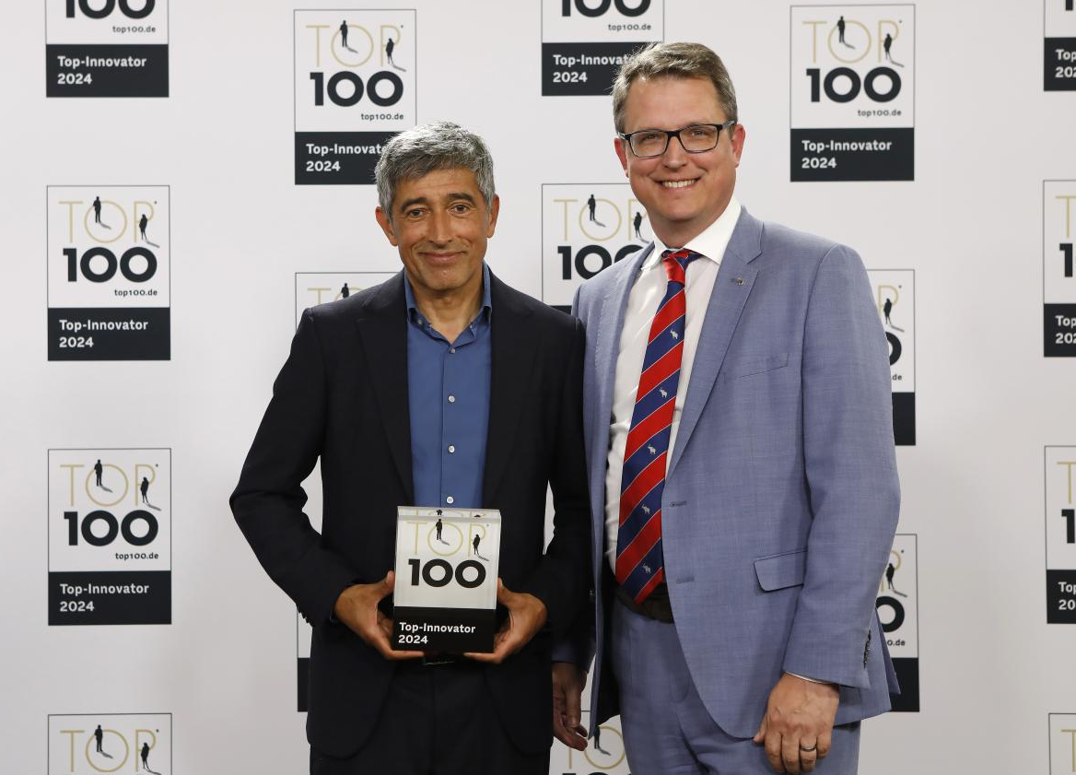
Picture credits: KD Busch / compamedia
Caption: Ranga Yogeshwar congratulates Marnix Lannoije, CTO at Schmitz Cargobull,
on being awarded the TOP 100 seal.

About Schmitz Cargobull
Schmitz Cargobull is the leading manufacturer of semi-trailers for temperature-controlled freight, general cargo and bulk goods in Europe and a pioneer in digital solutions for trailer services and improved connectivity. The company also manufactures transport refrigeration machines for refrigerated semi-trailers for temperature-controlled freight transport. With a comprehensive range of services from financing, spare parts supply, service contracts and telematics solutions to used vehicle trading, Schmitz Cargobull supports its customers in optimising their total cost of ownership (TCO) and digital transformation. Schmitz Cargobull was founded in 1892 in Münsterland, Germany. The family-run company produces
around 60,000 vehicles per year with over 6,000 employees and generated a turnover of around 2.6 billion euros in the 2022/23 financial year. The international production network currently comprises ten plants in Germany, Lithuania, Spain, England, Turkey, Slovakia and Australia.

The Schmitz Cargobull press team:
Anna Stuhlmeier +49 2558 81-1340 I anna.stuhlmeier@cargobull.com
Andrea Beckonert +49 2558 81-1321 I andrea.beckonert@cargobull.com
Silke Hesener +49 2558 81-1501 I silke.hesener@cargobull.com

