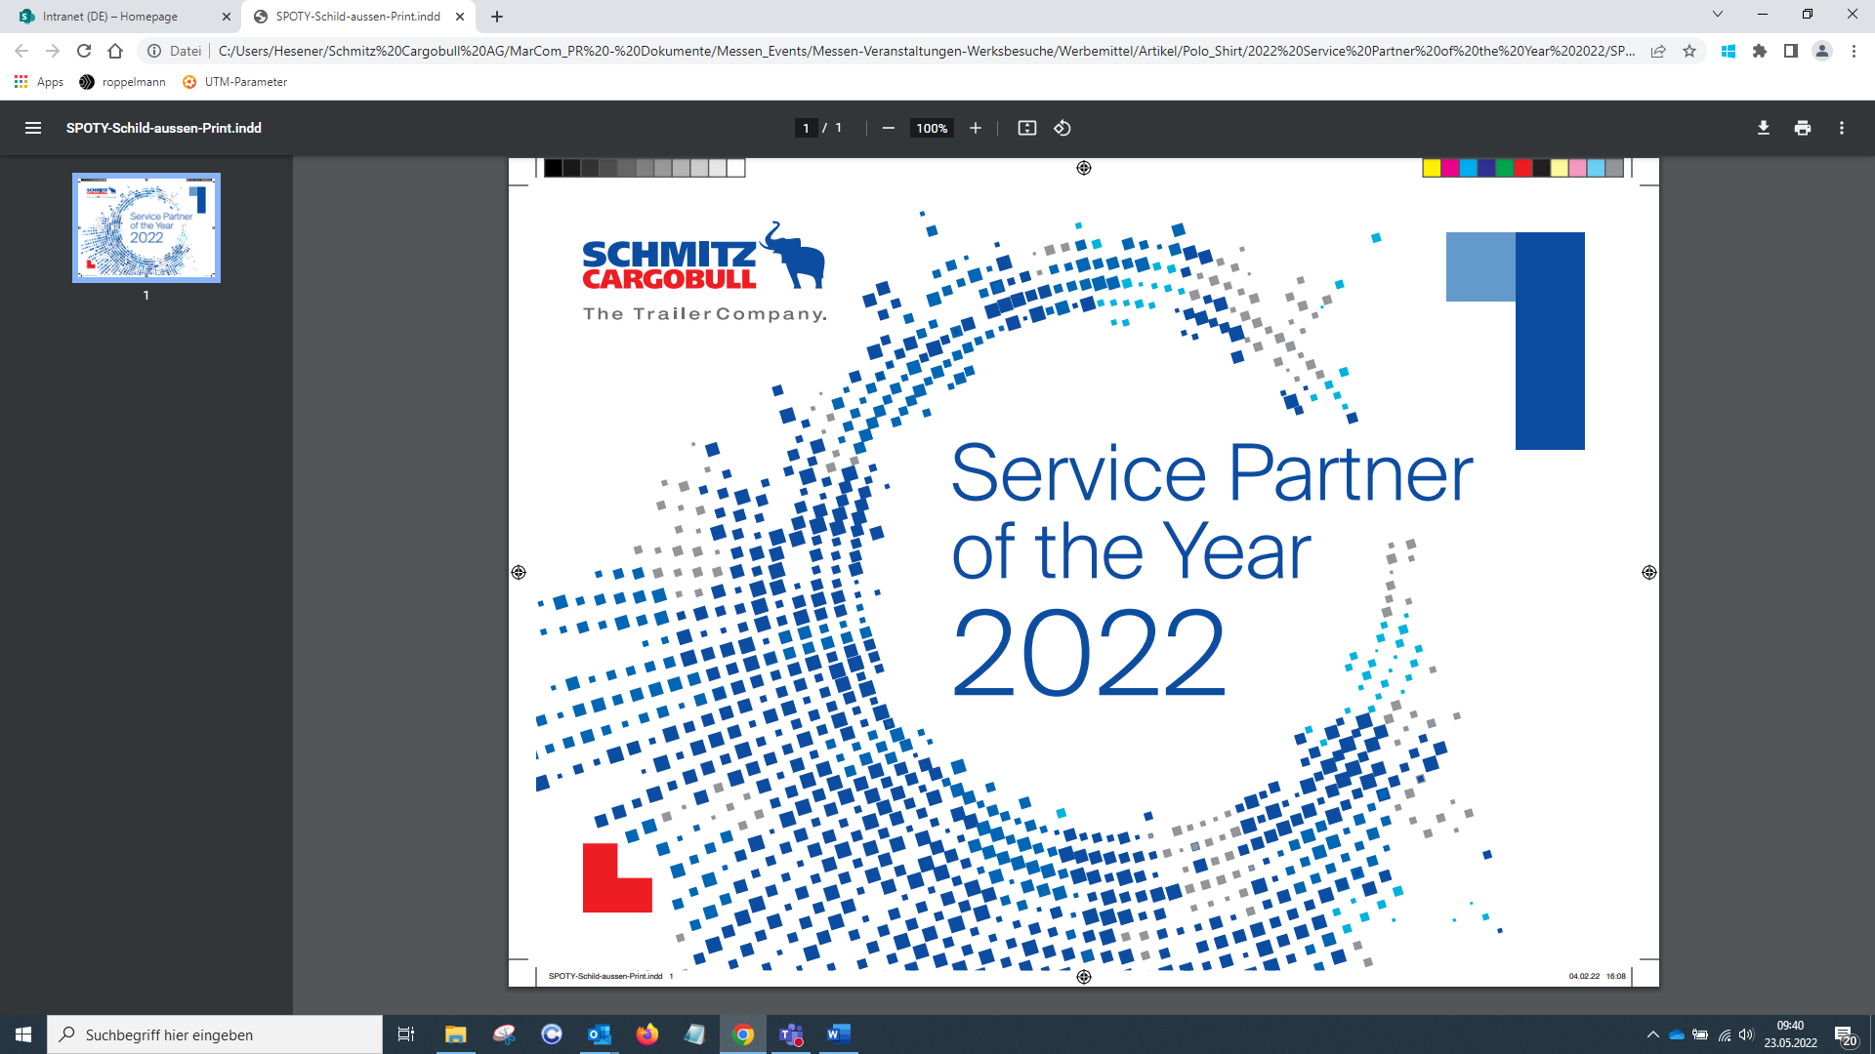
Press Release
2022-142

Schmitz Cargobull AG
Schmitz Cargobull announces "Service Partner of the Year" winners
Awards are presented to partners in 31 countries

November 2022 - Schmitz Cargobull has selected the best workshops and service centres from 31 countries in its Service Partner network.

The awards recognise partners who achieve the best workshop quality and customer service. The partner workshop must have delivered excellent results, especially in the categories "Breakdown service" and "Business development of spare parts". Optimal cooperation in handling full service contracts and warranty cases also influenced the selection of Service Partner of the Year awards.

Schmitz Cargobull attaches great importance to its nationwide network of authorised and trained service partners in over 40 countries. The workshops' customers benefit from the well-trained service technicians who specialise in Schmitz Cargobull products and who receive regular online or face-to-face training in the Cargobull Campus, the new training environment. This ensures the mobility of the vehicle fleet and minimises downtimes for all workshop services, whether on the trailer, the refrigeration machines or the in-house telematics system.

The acceptance rate of mediated breakdowns and the availability of spare parts and business development are deemed most important and deserving of recognition. For this reason, 31 Service Partner workshops in Europe received awards. The workshops and teams that work for Schmitz Cargobull customers every day make the company a strong and reliable brand in the service sector.

Schmitz Cargobull congratulates the winners and thanks them for their excellent cooperation.

2022-142
The Service Partner of the Year 2022 winners are:
Austria: Mossier GmbH
Bosnia/Herzegovina: Transkop d.o.o. Tuzla, P.J. Truck - Service
Belgium: Goethals Cooling BV
Bulgaria: Kurtev Service Bulgaria Ltd.
Switzerland: GREAG AG
Czech Republic: TURBOSOL Servis, s. r. o
Germany: ALS Anlagen Logistik Service
Denmark: Tip Trailer Services Denmark ApS
Estonia: Cargoservice OÜ
Spain: BALAGUER FRIO TRANSPORTE S.L.
Finland: F-Huolto
France: SARL B.S.F
Great Britain: BP commercials
Greece: Athanasios I. Theologis
Croatia : SARA Trans d.o.o.
Hungary: Rapid Teherautó Szerviz Kft.
Ireland: Mulvey Refrigeration Technology
Italy: Officine F.lli Giamundo S.a.s.
Kazakhstan: ТОО "СВС-ТРАНС"
Lithuania: Hanse Trailer
Latvia: Trailer Baltia SIA
Macedonia: TKC Servis DOOEL
Netherlands: Botlek Trailer Service B.V.
Norway: Team Verksted Follo AS
Poland: EWT Truck & Trailer Polska Sp. z o.o
Portugal: Confortruck
Romania: Emacris Trans SRL
Serbia: Braća Crnomarković
Sweden: HBG Transportkyla AB
Slovenia: Habjan Transport d.o.o.
Slovakia: NDŽ s.r.o.
2022-142

More information:
https://www.cargobull.com/en/trailer-services/service-partner-welt#SPOTY

About Schmitz Cargobull
With an annual production of around 61,000 trailers and with approximately 6,900 employees, Schmitz Cargobull AG is Europe’s leading manufacturer of semi-trailers, trailers and truck bodies for temperature-controlled freight, general cargo and bulk goods. The company achieved sales of around €2.3 billion in the 2021/22 financial year. As a pioneer in the industry, the North German company developed a comprehensive brand strategy early on and consistently established quality standards spanning every level: from research and development, through production and service contracts, to trailer telematics, financing, spare parts, and used vehicles.

The Schmitz Cargobull press team:
Anna Stuhlmeier +49 2558 81-1340 I anna.stuhlmeier@cargobull.com
Andrea Beckonert +49 2558 81-1321 I andrea.beckonert@cargobull.com
Silke Hesener +49 2558 81-1501 I silke.hesener@cargobull.com

