Press Release
2022-161

Schmitz Cargobull AG
Sustainable transport solution takes off
First hydrogen-powered motor vehicle chassis from Hyundai with Schmitz Cargobull body approved for road transport in Germany

November 2022 - Schmitz Cargobull has delivered the first climate-neutral vehicle combination of M.KO box body and hydrogen-powered motor to its customer hylane.

Manufactured at the Schmitz Cargobull production plant in Lithuania, the body is equipped with a multifunctional floor, two load-securing rails and a tail lift, completing the Hyundai hydrogen-powered vehicle. Assembly of the vehicle and the DEKRA inspection of it took place at the GRW plant in Toddin, where Schmitz Cargobull's project production is also still based. This development makes Schmitz Cargobull the first certified bodybuilder for Hyundai in Germany.

Dirk Nuxoll, Managing Director GRW, Sabine Essmann, International Key Account Manager Logistic/Food Business at Schmitz Cargobull, and Bruno Altenschöpfer, Fleet Manager at hylane, took delivery of the vehicle for its first use on the road.

"I am thrilled at how quickly this concept could be implemented. This vehicle is another step forward for sustainable transport solutions with hydrogen in Germany," says Altenschöpfer.

"Solutions for sustainable freight transport are particularly important to Schmitz Cargobull. We are pleased to realise this great pilot project in such a short time and will complete a total of 17 vehicles in the next few weeks. The box bodies from Schmitz Cargobull are optimally equipped to accommodate the hydrogen tanks on the bulkhead," says Essmann.

" As the first hydrogen series truck to be approved in Germany, we were able to show the vehicle together with Schmitz Cargobull at the BMDV conference "Climate-friendly commercial vehicles" in Berlin. There we were also allowed to present our concept for the practical use of the trucks in detail", says Sara Schiffer, Managing Director, HyLane
2022-161

GmbH. “Vehicles of the type "XCIENT Fuel Cell" will be prepared – depending on customer requirements - for their use on the road. Refrigerated and dry freight boxes are mounted on the motor vehicle chassis in order to be able to safely transport the goods. Some of the vehicles will also be fitted with a refrigerated trailer."

As an exclusive provider of climate-neutral mobility vehicles for rent, hylane offers competitive rates thanks to funding from the Federal Ministry of Digital Affairs and Transport. Customers only pay for the kilometres they actually drive. As a hylane customer, you not only save CO₂ - a certificate of the individual CO₂ savings is issued - but also costs.

Further information on Hyundai trucks and other rentable hydrogen vehicles is available at www.hylane.de.

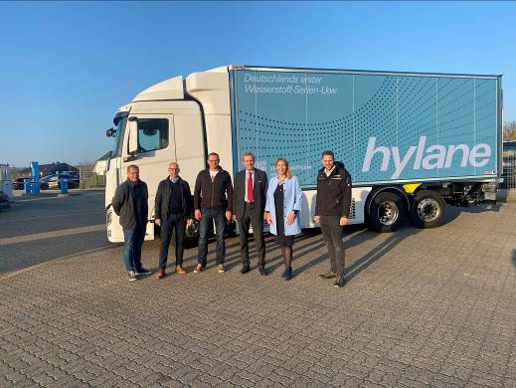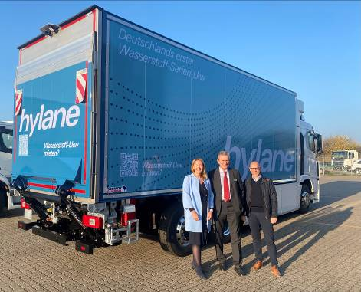
Caption1: f. l.: Andreas Kirchner, Dirk Nuxoll (both GRW), Danijel Babic (Hyundai),
Bruno Altenschöpfer (Hylane), Sabine Essmann (Schmitz Cargobull), R. Keiten-Schmitz (Dekra)

Caption2: f. l.: Sabine Essmann, Bruno Altenschöpfer, Dirk Nuxoll

About Schmitz Cargobull
With an annual production of around 61,000 trailers and with approximately 6,900 employees, Schmitz Cargobull AG is Europe’s leading manufacturer of semi-trailers, trailers and truck bodies for temperature-controlled freight, general cargo and bulk goods. The company achieved sales of around €2.3 billion in the 2021/22 financial year. As a pioneer in the industry, the North German company developed a comprehensive brand strategy early on and consistently established quality standards spanning every level: from research and development, through production and service contracts, to trailer telematics, financing, spare parts, and used vehicles.

The Schmitz Cargobull press team:
Anna Stuhlmeier +49 2558 81-1340 I anna.stuhlmeier@cargobull.com
Andrea Beckonert +49 2558 81-1321 I andrea.beckonert@cargobull.com
Silke Hesener: +49 2558 81-1501 I silke.hesener@cargobull.com

