Press Release
2022-308

Schmitz Cargobull AG

The new curtainsider semi-trailer - S.CS FREEPOST for the UK and Irish markets

- Body without sliding posts for free and safe side loading
- Certified to DIN EN 12642 Code XL
- Produced at the Schmitz Cargobull UK plant in Manchester

November 2022 - Schmitz Cargobull, Europe's leading manufacturer of semi-trailers,
has added a new product to its General Cargo portfolio. The new S.CS FREEPOST curtainsider semi-trailer has been specially developed to meet the requirements of the
UK and Irish markets, without the need for sliding posts and is manufactured at the Schmitz Cargobull UK production plant in Manchester.

The United Kingdom and The Republic of Ireland are both important transport and logistics locations. Schmitz Cargobull therefore offers a product portfolio from the new Manchester plant that is specifically tailored to the needs of UK and Irish transport operators.

"We successfully launched production, at our Manchester plant, in June 2021 with the production of the market specific S.BO PACE and S.CS FIXED ROOF curtainsider semi-trailers. We are now pleased to be able to offer our customers the S.CS FREEPOST curtainsider semi-trailer, without the need of sliding posts, from our proven modular system," explains Paul Avery, Managing Director - Operations at Schmitz Cargobull UK.

Matthias Muffert, Head of Product Management General Cargo at Schmitz Cargobull, adds: "Before the start of series production, we subjected the S.CS FREEPOST to a series of rigorous tests. The vehicle, which is equipped with a fixed aluminium roof, galvanised steel cant rails and a reinforced chassis structure, also meets the strict TÜV test requirements, with its low tare weight, and is certified to DIN EN 12642 Code XL.
Our customers can rely on a high-quality curtainsider with maximum safety for general freight transport."

2022-308

In addition to high body stability, the design of the S.CS FREEPOST is also focused on handling, the safety of the goods and the safety of the driver and loaders. It is available in different heights from 4,200 mm to 4,800 mm.
The S.CS FREEPOST does not require any sliding posts and offers the driver-free, lateral loading and unloading with a side aperture height of up to 3,200 mm. To facilitate unloading, the curtain can be tensioned from both the front and the rear. Additional driver safety is provided by the Schmitz Cargobull Susi-Rail, with which the electrical and pneumatic connections can be moved to the edge of the trailer and hence trailer coupling can be made without climbing between the tractor and trailer.

Flexible load securing points, with continuous lashing holes in the side rave and an optional 16 pairs of 4t lashing rings are available for optimum load securing. Load shift can be prevented by optional load securing straps, which are tensioned from the rave to the roof track. Additional security against unauthorised access is provided by a 1.8 metre high anti-slash mesh integrated inside the curtains.

Like all Schmitz Cargobull trailers, the S.CS FREEPOST is also equipped with the proven repair-friendly MODULOS chassis with a 10-year guarantee against rust-through. The chassis is complemented by the ROTOS axles and suspension, which are guaranteed for 1,000,000 km or six years*.

The trailer is also fitted with the TrailerConnect® telematics system from Schmitz Cargobull, which is fitted as standard ex-works. TrailerConnect® offers intelligent connectivity and supports rapid diagnosis and processing of the collected data from
all components.

*depending on which comes first

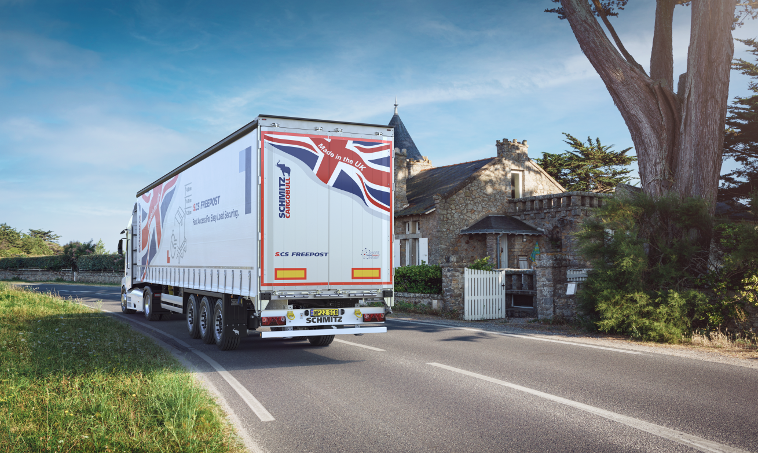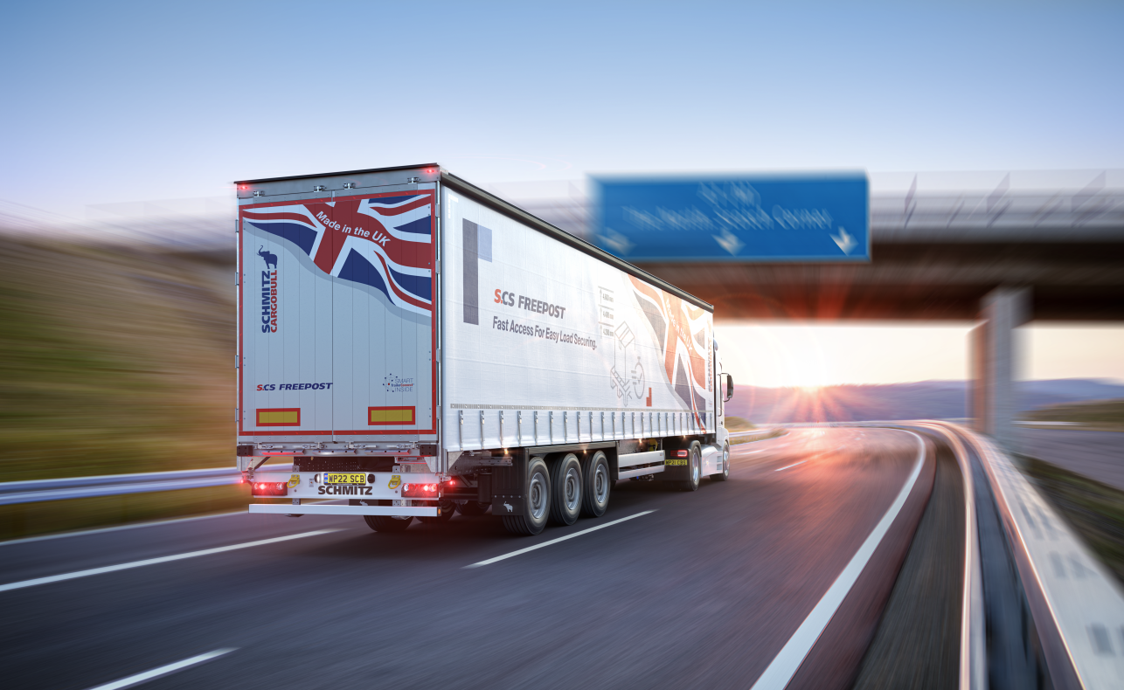

About Schmitz Cargobull
With an annual production of around 61,000 trailers and with approximately 6,900 employees, Schmitz Cargobull AG is Europe’s leading manufacturer of semi-trailers, trailers and truck bodies for temperature-controlled freight, general cargo and bulk goods. The company achieved sales of around €2.3 billion in the 2021/22 financial year. As a pioneer in the industry, the North German company developed a comprehensive brand strategy early on and consistently established quality standards spanning every level: from research and development, through production and service contracts, to trailer telematics, financing, spare parts, and used vehicles.

The Schmitz Cargobull press team:
Anna Stuhlmeier +49 2558 81-1340 I anna.stuhlmeier@cargobull.com
Andrea Beckonert +49 2558 81-1321 I andrea.beckonert@cargobull.com
Silke Hesener +49 2558 81-1501 I silke.hesener@cargobull.com

