Press Release
2021-112

Schmitz Cargobull AG
Schmitz Cargobull starts trailer production in the UK

June 2021 – Schmitz Cargobull, Europe's leading manufacturer of semi-trailers, is opening a new factory in Manchester to build customised vehicles for UK and Irish operators.

Andreas Schmitz, Chief Executive Officer at Schmitz Cargobull, says: “The UK is a key transport and logistics market and an important semi-trailer and rigid truck market for us. With the new plant we are moving closer to our customers and ensuring that we can address their needs offering the most reliable chassis and a proven local body.”

Production at the 7,500 sq m facility in Wythenshawe, Greater Manchester, is scheduled to start this summer with a capacity of 50 units per week including freepost curtainsiders and box van semi-trailers.

The site will also contain a 1,000 sq m spare parts warehouse for local supply and by the end of this year will become the main base for the complete Schmitz Cargobull UK team. Managing Directors of Schmitz Cargobull UK are jointly Paul Avery for operations and Alan Hunt for the sales and service activities.

The new operation joins an extensive Schmitz Cargobull production network including German facilities in Vreden, Altenberge, Gotha and Toddin, as well as bases in Lithuania, Russia, Spain, Turkey and Australia.

Boris Billich, Director of Sales at Schmitz Cargobull, says: “We want to support transport companies in the UK and Ireland in a best possible way with our comprehensive range of reliable and innovative transport solutions. This includes vehicles with market-specific features, shortest possible delivery times, an extensive 24/7 spare parts supply as well as our proven range of services from financing to telematics and used vehicle sales.”
2021-112

With a network of highly flexible production plants, Schmitz Cargobull is able to quickly respond to local market requirements and currently produces around 46,000 trailers on an annual basis.

The family-owned business is synonymous with reliability and innovation and guarantees consistently high quality standards across its global operation, from vehicle configuration to handover to the customer.

Its aftercare sales support is based on an authorized network of 1,700 workshops located across the UK, Ireland and in Europe.

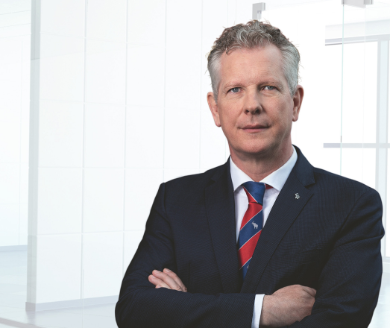
From the left.: Andreas Schmitz CEO and Boris Billich CSO Schmitz Cargobull

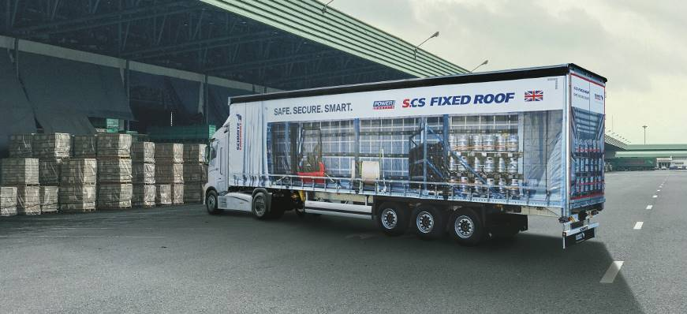
Semi-trailer S.CS Fixed Roof is specially designed for the UK market

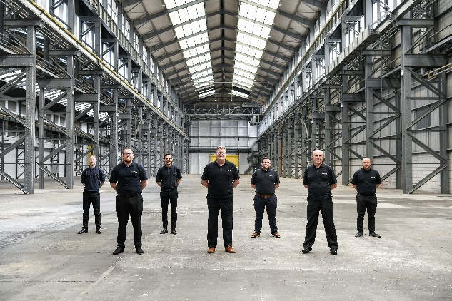
Paul Avery (centre) is waiting in the wings with his production team.

2021-112

About Schmitz Cargobull
With an annual production of around 46,100 trailers and with around 5,700 employees, Schmitz Cargobull AG is Europe’s leading manufacturer of semi-trailers, trailers and truck bodies for temperature-controlled freight, general cargo and bulk goods. The company achieved sales of approximately €1.87 billion in the 2019/2020 financial year. As a pioneer in the industry, the North German company developed a comprehensive brand strategy early on and consistently established quality standards spanning every level: from research and development, through production and service contracts, to trailer telematics, financing, spare parts, and used vehicles.

The Schmitz Cargobull press team:
Anna Stuhlmeier +49 2558 81-1340 I anna.stuhlmeier@cargobull.com
Andrea Beckonert +49 2558 81-1321 I andrea.beckonert@cargobull.com
Silke Hesener +49 2558 81-1501 I silke.hesener@cargobull.com

