Press Release
2024-801

Schmitz Cargobull AG
Efficient solutions for multi-modal transport
The A.WF trailer swap chassis, Z.WF central axle swap chassis and W.BO swap box from Schmitz Cargobull

June 2024 – Increasing traffic density on the roads, the corresponding carbon dioxide emissions together with many shipping companies demanding green logistics is making multi-modal transport increasingly important for general cargo transport tasks on a European level. Fast swapping between road and rail, the safety of the freight and the flexibility of the trailers needed place stringent demands on vehicle producers.
Schmitz Cargobull’s proven modular system provides optimum trailer solutions and equipment for multi-modal transport not only for S.KO refrigerated box body semi-trailers, S.BO dry freight semi-trailers and S.CS curtainsider semi-trailers. Over the last several years, Schmitz Cargobull has also reintroduced the A.WF and Z.WF swap chassis for transporting swap containers, as well as a W.BO swap box, for an effective multi-modal solution.

The trailers for swap body operations have a large range of ground clearances, making them especially adaptable, and they are distinguished by their simple and sturdy design. Optimally equipped to facilitate the rough swap operations, they enable economical handling of swap containers. The chassis are available in a proven hot-dip galvanised design.

With its robust two-axle steel chassis and locks for 1 x 20’ containers, the A.WF trailer swap chassis provides the optimum equipment for securing and supporting swap containers. It has been optimally designed to meet the demands of multi-modal transport and is capable of flexibly transporting 7.15 and 7.45 swap boxes and containers.

The Z.WF central axle swap chassis is also designed to flexibly transport 7.45 and 7.82 interchangeable containers and containers. Designed and tested for every type of transport task with a payload of approximately 14.5 tonnes, both trailers are suitable for transporting containers and swap bodies with standardised ISO container mountings (20’).

2024-801

The hot-dip galvanised chassis is resistant to corrosion and offers optimum protection against rust-through. A ten-year warranty against rust-through applies to all galvanised parts in the chassis. This contributes to the value retention of the chassis, which is clearly reflected in the resale value. Galvanising offers optimum surface protection for commercial vehicles, as the conventional mechanical stresses of everyday transport do not leave any permanent impact.

Schmitz Cargobull’s product range also includes the W.BO swap box as a solution for multi-modal transport. Instead of losing time during loading and unloading, swap containers can be set down and immediately replaced by another swap container ready for further transport. In addition to saving time, this helps the transport vehicle to be used more efficiently. Furthermore, the driving times per driver are reduced and empty runs are avoided.

The Schmitz Cargobull W.BO swap box for dry freight transport is a swap box in a steel design with a wide range of equipment options, such as a double-decker system, roller door or standard keyhole system. Schmitz Cargobull offers three different swap box models, which are designed to handle a wide range of transport tasks. They are available in steel with a length of 7.45 m and either smooth or beaded walls, and with a length of 7.82 m and smooth walls.

The swap chassis are developed, designed and produced by Schmitz Cargobull at its site in Michalovce, Slovakia. The new W.BO swap boxes are produced by Schmitz Cargobull’s cooperation partner and body specialist Kerex in Michalovce.

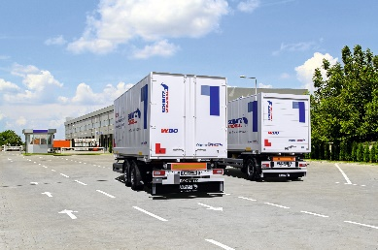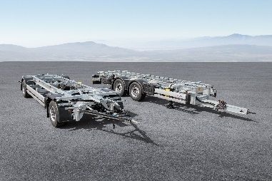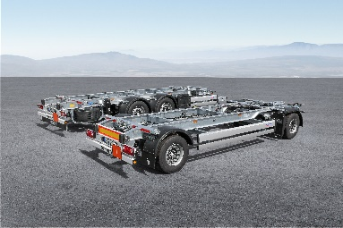

2024-801

About Schmitz Cargobull
Schmitz Cargobull is the leading manufacturer of semi-trailers for temperature-controlled freight, general cargo and bulk goods in Europe, and a pioneer in digital solutions for trailer services and improved connectivity. The company also manufactures transport cooling units for refrigerated box body semi-trailers for temperature-controlled freight transport. With a comprehensive range of services from financing, spare parts supply, service contracts and telematics solutions to used vehicle trading, Schmitz Cargobull supports its customers in optimising their total cost of ownership (TCO) and digital transformation. Schmitz Cargobull was founded in 1892 in Münsterland, Germany. The family-run company produces around 60,000 vehicles per year with over 6,000 employees, and generated a turnover of around €2.6 billion in the 2022/23 financial year. The international production network currently comprises ten plants in Germany, Lithuania, Spain, England, Turkey, Slovakia and Australia.

The Schmitz Cargobull press team:
Anna Stuhlmeier +49 2558 81-1340 I anna.stuhlmeier@cargobull.com
Andrea Beckonert +49 2558 81-1321 I andrea.beckonert@cargobull.com
Silke Hesener +49 2558 81-1501 I silke.hesener@cargobull.com

