Press release
2024-138

Schmitz Cargobull
Schmitz Cargobull strengthens its market position by acquiring a majority stake in Atlantis Global System, the Spanish telematics specialist for refrigerated logistics

Zaragoza, June 2024 - Schmitz Cargobull AG has acquired a majority stake in Atlantis Global System (AGS), the leading Spanish manufacturer of telematics solutions for monitoring and maintaining the cold chain. With its innovative telematics solutions, AGS is represented in most of the 50 largest companies for the transport of temperature-controlled goods in Spain.
With this acquisition, Schmitz Cargobull, Europe's largest manufacturer of semi-trailers, will continue increasing its leadership for the most modern telematics system for refrigerated semi-trailers together with AGS. A system that fulfils the highest requirements in refrigerated transport and along the entire cold chain.

The AGS telematics system for real-time refrigeration data will be available with immediate effect for all Schmitz Cargobull refrigerated semi-trailers produced at the Zaragoza plant. The data from the TrailerConnect® telematics system, which Schmitz Cargobull integrates as standard in all its semi-trailers, will also be made available on the AGS telematics platform. On customer request, the telematics data from the AGS system will be available within the Schmitz Cargobull TrailerConnect® portal.

Atlantis Global System, AGS, will remain an independent cold chain specialist within the Schmitz Cargobull Group and will continue to operate independently in the market to ensure the best service for customers.

Founder Rafael del Pino, who will continue as CEO of AGS, explains: "The partnership with Schmitz Cargobull is an important step to strengthen and further develop the solutions developed by AGS in Spain. It offers a great opportunity to promote new products and further develop advanced fleet management solutions."

2024-138

The smartest and best-connected refrigerated semi-trailer on the market
Schmitz Cargobull's refrigerated semi-trailers already have the best global connection on the market and, in combination with the technology developed by AGS, it will also allow the semi-trailer to be integrated into the customer’s logistic system. An improved overview of the entire cold chain sets it apart from the competition.

To celebrate the cooperation, Schmitz Cargobull and AGS are offering a special welcome package for customers in Spain. Together with the Schmitz Cargobull refrigerated box body, the TrailerConnect® telematics and the AGS intelligent temperature recorder (thermograph) will be combined with refrigeration units from Schmitz Cargobull and other manufacturers. The complete package will be manufactured and installed at the new Schmitz Cargobull plant in Zaragoza with Schmitz Cargobull taking full responsibility for a seamless integration.

Schmitz Cargobull set important milestones in the financial year 2023/24: The opening of the new plant in Zaragoza; the strategic alliance with the Austrian manufacturer for lightweight trailers Berger; the opening of new locations in Georgia and Kazakhstan; and the successful entry into the US market with Schmitz Cargobull’s transport refrigeration units are some of the milestones that contribute to the group’s growth. These developments are now complemented by the majority shareholding in AGS. It underlines the company's ongoing commitment to excellence and global expansion, consolidating its position as a global player in the transport sector.

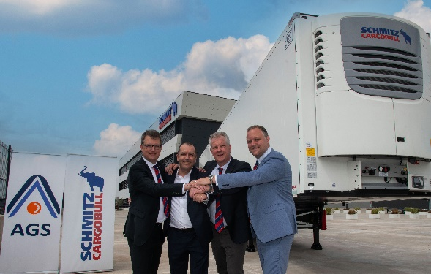
Caption: from left: Marnix Lannoije, CTO Schmitz Cargobull, Rafael del Pino, CEO AGS, Andreas Schmitz, CEO Schmitz Cargobull, Stefan Grawe, Head of R&D Project Management

2024-138

About Schmitz Cargobull
Schmitz Cargobull is the leading manufacturer of semi-trailers for temperature-controlled freight, general cargo and bulk goods in Europe and a pioneer in digital solutions for trailer services and improved connectivity. The company also manufactures transport refrigeration machines for refrigerated semi-trailers for temperature-controlled freight transport. With a comprehensive range of services from financing, spare parts supply, service contracts and telematics solutions to used vehicle trading, Schmitz Cargobull supports its customers in optimising their total cost of ownership (TCO) and digital transformation. Schmitz Cargobull was founded in 1892 in Münsterland, Germany. The family-run company produces around 60,000 vehicles per year with over 6,000 employees and generated a turnover of around 2.6 billion euros in the 2022/23 financial year. The international production network currently comprises ten plants in Germany, Lithuania, Spain, England, Turkey, Slovakia and Australia.

About AGS, Atlantis Global System
A Spanish company that has set a milestone in the development of the refrigerated industry. Founded in 2004 by Rafael del Pino from Almeria, Atlantis Global System, S.L.U. (AGS) began its activity with the development of management solutions and telematic control of goods transport vehicles using GPS tracking devices. Throughout its 20-year history, AGS has continued to innovate in order to integrate technologies and services that meet the needs of its customers and cold stores in food and/or pharmaceutical distribution centres.

In 2011, AGS presented the first telematic digital thermograph, which can monitor the temperature of goods in real time. The new device also included the innovation that it can be used not only in vehicles, but also in the cold rooms of distribution centres for food and/or medicines.

In 2013, AGS obtained certification for the use of Module D in the manufacture of its telematic digital thermograph, Conecta+ Termotel, and a year later the company moved its facilities to the Almeria Science and Technology Park,

In 2015, AGS's professional solutions for transport and cold storage in distribution centres were certified in accordance with Annex 11 of the "Guide to Good Manufacturing Practice for Human and Veterinary Medicinal Products" required by the Ministry of Health. A year later, in 2016, the company was honoured with the Andalucía Excelente Award.

In 2017, AGS launches the AGS Termotel S, the first modular telematic digital thermometer with the aim of making management and maintenance even easier for the user. In the event of a malfunction, for example, only the damaged module needs to be repaired or replaced, while the rest of the system remains fully functional. In addition, this process can be carried out by the user himself. The new Termotel S also has improved energy efficiency (the lowest in its segment).

In 2021, it launched a new generation of solutions on the market that represented a major leap forward for the refrigeration industry The new flagship product from AGS is the Conecta+ iTS Compact digital compact thermograph, which has an equipment option for stand-alone and portable use. iTS Compact combines the temperature recorder and the sensor electronics in a single ultra-compact device and can be used both in the vehicles that transport the goods and in the cold rooms of the distribution centres where they are stored.

Today, AGS technology offers telematics coverage throughout Europe and North Africa, with a large and prestigious customer base in the Spanish market. Over the years, our customers in the food industry have been joined by service companies, cranes, breakdown services, parcel delivery companies, commercial fleets and companies in the pharmaceutical sector that require this technology for the optimal storage of their medicines.

The Schmitz Cargobull press team:
Luis Bonasa: +34 976 613 200 - 5230 I luis.bonasa@cargobull.com
Raquel Villarrroya: +34 976 613 200 - 5229 I raquel.villarroya@cargobull.com
Anna Stuhlmeier: +49 2558 81-1340 I anna.stuhlmeier@cargobull.com

